**IFT 530: Advanced Database Management System**

**Assignment: Final Project**

Group 16

[Jahnavi Lasyapriya Vavilala](mailto:lasyapriya.vavilala@gmail.com)[1231997652]

Sruthi Keerthana Nuttakki [1232316477]

**Submitted to:**

**Prof. Ashish Gulati**

**Dec 6, 2024**

**TABLE OF CONTENTS**

***Project: Database Management for Sentiment Analysis on Social Media.***

1. *Summary*
2. *Tables*
3. *ERD Diagram*
4. *Views*

* *View 1: Positive Sentiment Posts by Platform*
* *View 2: Active users with high engagement*
* *View 3: Active_users_Insights*

1. *Triggers*
2. *Stored Procedures*
3. *User Defined Functions*
4. *Cursors*

### **TOPIC: DATABASE MANAGEMENT FOR SENTIMENT ANALYSIS ON SOCIAL MEDIA**

Summary:

**1. ABSTRACT AND USE OF THE TABLES**

Social media is an engaging two-way platform fostering communication amongst the customers and brands/ events. With social media gaining popularity in recent years, it can be leveraged to understand brands’ perception in the public. Sentiment analysis determines the opinion of customers allowing businesses to optimize their products/ services. Apart from businesses sentiment analysis is helpful in law enforcement, research, education, journalism, entertainment etc. Therefore, with sentiment analysis one can understand the trends, public opinion, engagement to reflect on decision making. Using Natural Language Processing (NLP), Machine Learning (ML) and text classification sentiments are grouped into positive, negative and neutral.

In the scope of this project, a database system will be created to handle volumes of data for efficient storage, organization and retrieval. A database system ensures high querying, allows cross platform analysis and facilitates easy updation.

In this project, there would be 8 tables and 2 fact tables as follows:

**Main Tables**:

1. **Users**: Information about social media users (anonymous identifiers).
2. **Posts**: Raw social media posts (content, metadata).
3. **Platforms**: Details about social media platforms.
4. **Hashtags**: Track hashtags used in posts.
5. **Keywords**: Identify key terms for sentiment analysis.
6. **Sentiment_Scores**: Store sentiment scores for analyzed posts.
7. **Languages**: Store supported languages.
8. **Locations**: Record the geographical location of posts.

**Fact Tables**:

1. **Post_Analytics**: Aggregate data for posts (e.g., likes, shares, comments).
2. **Sentiment_Trends**: Store trends over time (e.g., average sentiment by day).

**Task 1: Create the tables using SQL script you have defined in the Final project.**

Execution of creating Database named Group16 and using it for the project

Code:

CREATE DATABASE Group16;

GO

USE Group16;

GO

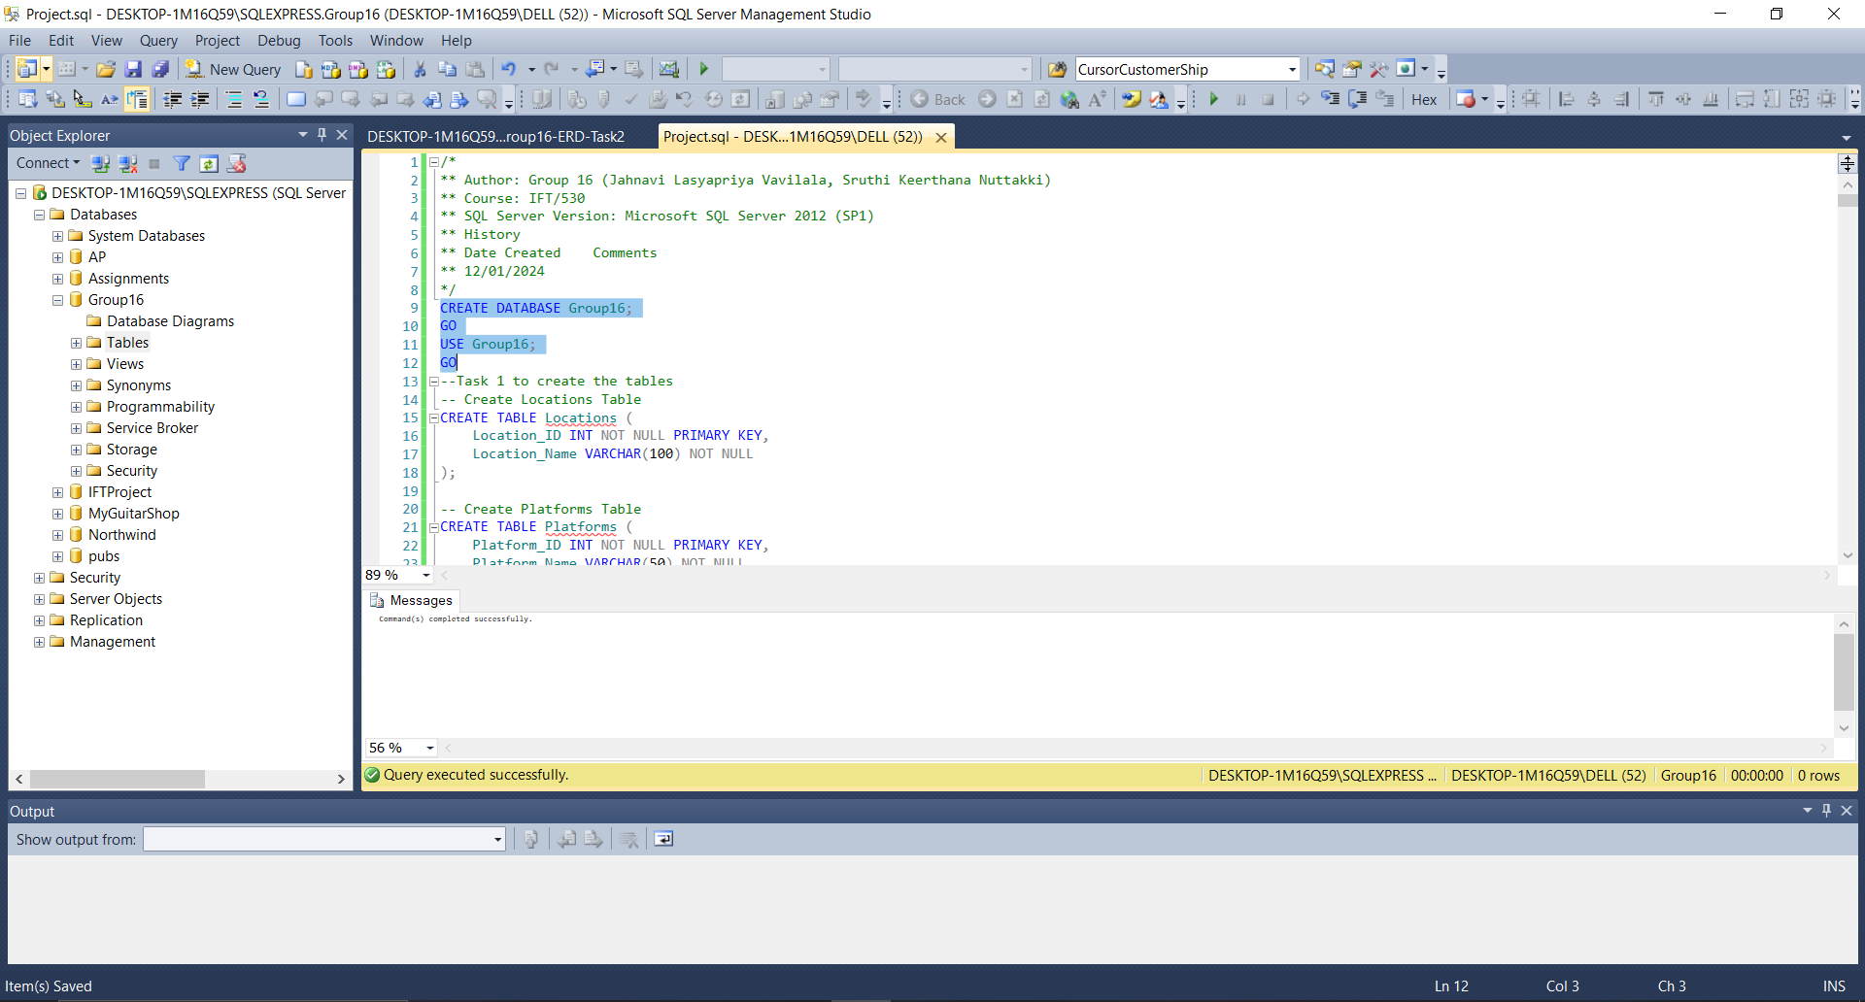

Execution of creation of Tables as defined

Code:

/*

** Author: Group 16 (Jahnavi Lasyapriya Vavilala, Sruthi Keerthana Nuttakki)

** Course: IFT/530

** SQL Server Version: Microsoft SQL Server 2012 (SP1)

** History

** Date Created Comments

** 12/01/2024

*/

CREATE DATABASE Group16;

GO

USE Group16;

GO

--Task 1 to create the tables

-- Create Locations Table

CREATE TABLE Locations (

Location_ID INT NOT NULL PRIMARY KEY,

Location_Name VARCHAR(100) NOT NULL

);

-- Create Platforms Table

CREATE TABLE Platforms (

Platform_ID INT NOT NULL PRIMARY KEY,

Platform_Name VARCHAR(50) NOT NULL

);

-- Create Languages Table

CREATE TABLE Languages (

Language_ID INT NOT NULL PRIMARY KEY,

Language_Name VARCHAR(50) NOT NULL UNIQUE

);

-- Create Users Table

CREATE TABLE Users (

User_ID INT NOT NULL PRIMARY KEY,

Username VARCHAR(50) NOT NULL,

Age INT CHECK (Age >= 13),

Gender CHAR(1),

Location_ID INT,

FOREIGN KEY (Location_ID) REFERENCES Locations(Location_ID)

);

-- Create Posts Table

CREATE TABLE Posts (

Post_ID INT NOT NULL PRIMARY KEY,

User_ID INT NOT NULL,

Platform_ID INT NOT NULL,

Post_Content TEXT NOT NULL,

Language_ID INT,

Post_Date DATETIME NOT NULL,

Hashtags TEXT,

Keywords TEXT,

FOREIGN KEY (User_ID) REFERENCES Users(User_ID),

FOREIGN KEY (Platform_ID) REFERENCES Platforms(Platform_ID),

FOREIGN KEY (Language_ID) REFERENCES Languages(Language_ID)

);

-- Create Hashtags Table

CREATE TABLE Hashtags (

Hashtag_ID INT NOT NULL PRIMARY KEY,

Hashtag_Text VARCHAR(100) NOT NULL UNIQUE

);

-- Create Keywords Table

CREATE TABLE Keywords (

Keyword_ID INT NOT NULL PRIMARY KEY,

Keyword_Text VARCHAR(100) NOT NULL UNIQUE

);

-- Create Sentiment_Scores Table

CREATE TABLE Sentiment_Scores (

Score_ID INT NOT NULL PRIMARY KEY,

Post_ID INT NOT NULL,

Sentiment_Score DECIMAL(3, 2) NOT NULL CHECK (Sentiment_Score BETWEEN -1.00 AND 1.00),

FOREIGN KEY (Post_ID) REFERENCES Posts(Post_ID)

);

-- Create Post_Analytics Fact Table

CREATE TABLE Post_Analytics (

Analytics_ID INT NOT NULL PRIMARY KEY,

Post_ID INT NOT NULL,

Likes_Count INT NOT NULL DEFAULT 0,

Shares_Count INT NOT NULL DEFAULT 0,

Comments_Count INT NOT NULL DEFAULT 0,

Views_Count INT NOT NULL DEFAULT 0,

Engagement_Rate DECIMAL(5, 2) NOT NULL DEFAULT 0,

Analysis_Date DATETIME NOT NULL,

FOREIGN KEY (Post_ID) REFERENCES Posts(Post_ID)

);

-- Create Sentiment_Trends Fact Table

CREATE TABLE Sentiment_Trends (

Trend_ID INT NOT NULL PRIMARY KEY,

Platform_ID INT NOT NULL,

Date DATE NOT NULL,

Avg_Sentiment DECIMAL(3, 2) NOT NULL CHECK (Avg_Sentiment BETWEEN -1.00 AND 1.00),

Post_Count INT NOT NULL DEFAULT 0,

Positive_Ratio DECIMAL(5, 2) NOT NULL CHECK (Positive_Ratio BETWEEN 0 AND 100),

Negative_Ratio DECIMAL(5, 2) NOT NULL CHECK (Negative_Ratio BETWEEN 0 AND 100),

Neutral_Ratio DECIMAL(5, 2) NOT NULL CHECK (Neutral_Ratio BETWEEN 0 AND 100),

FOREIGN KEY (Platform_ID) REFERENCES Platforms(Platform_ID)

);

Note: Please execute the tables with no reference to another table first so that there will be no FK error.

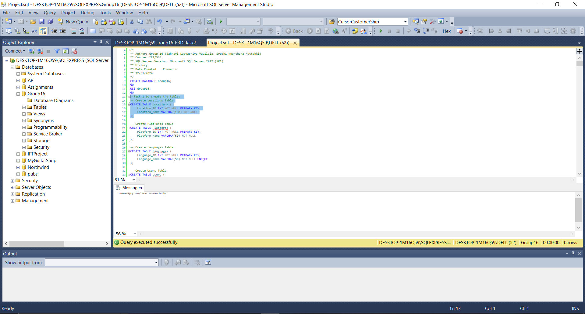

Executed script to see the created tables:

Code:

-- Script to see the tables

SELECT * FROM Locations;

SELECT * FROM Platforms;

SELECT * FROM Languages;

SELECT * FROM Users;

SELECT * FROM Keywords;

SELECT * FROM Hashtags;

SELECT * FROM Posts;

SELECT * FROM Sentiment_Scores;

SELECT * FROM Post_Analytics;

SELECT * FROM Sentiment_Trends;

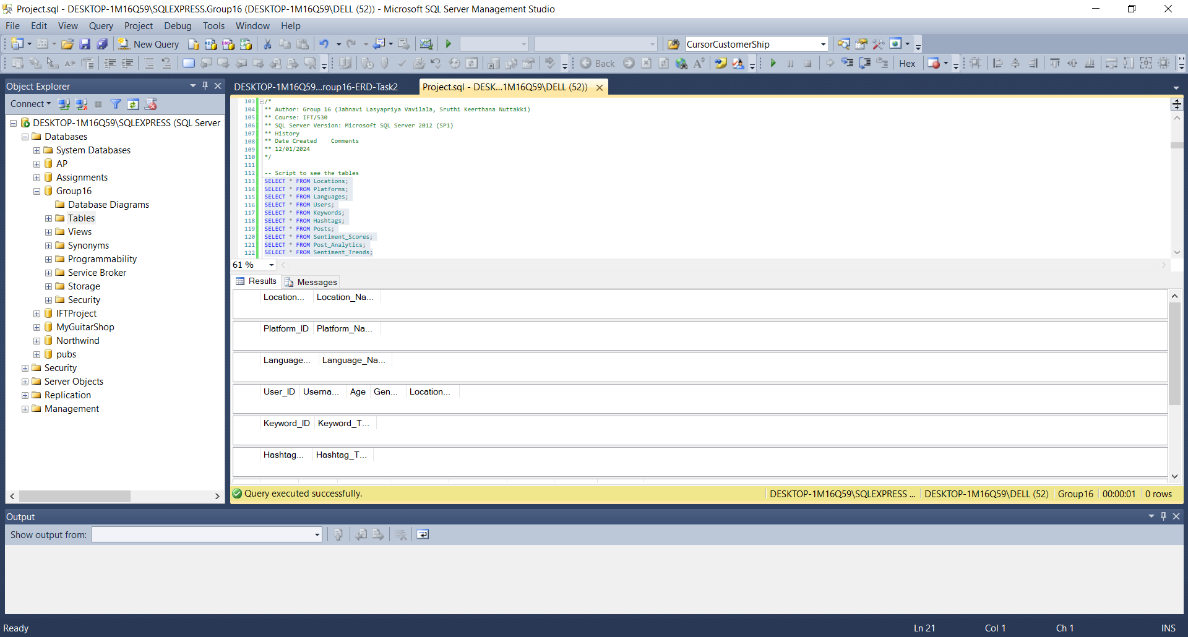

**Task 2: Generate the ERD diagram and paste it in a word document.**

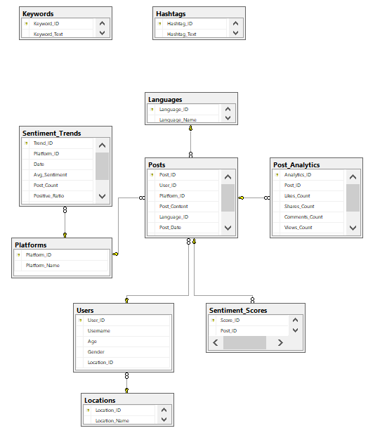

**Task 3:**

**Populate the table with 10 rows for dimension tables, 20 – 50 rows for transactional tables.**

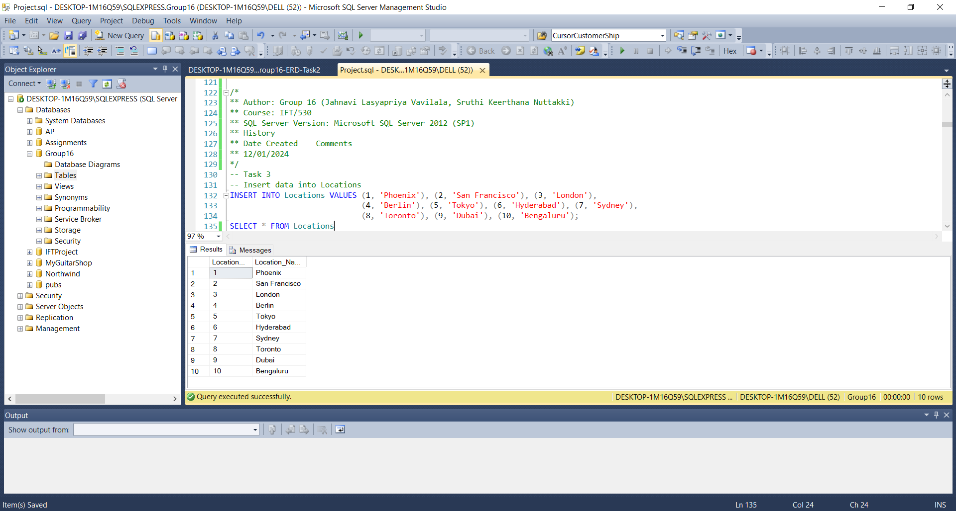

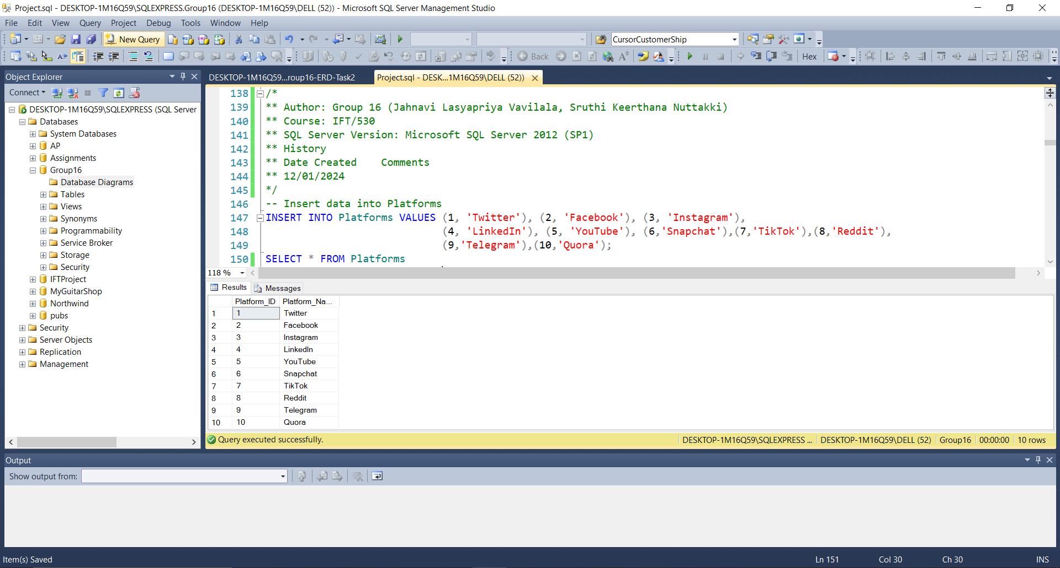

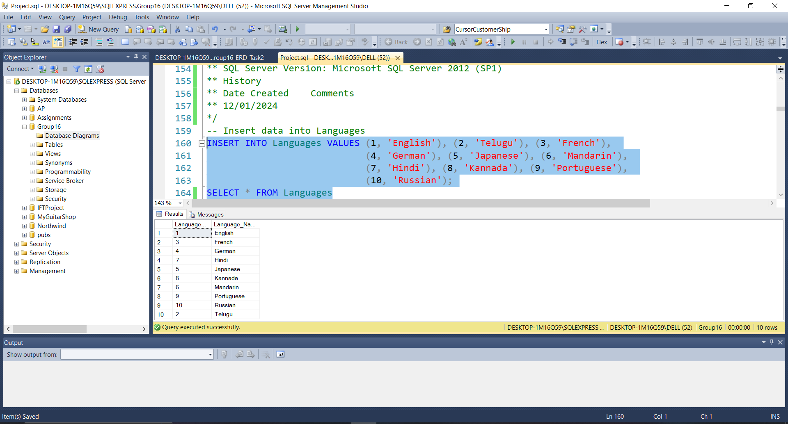

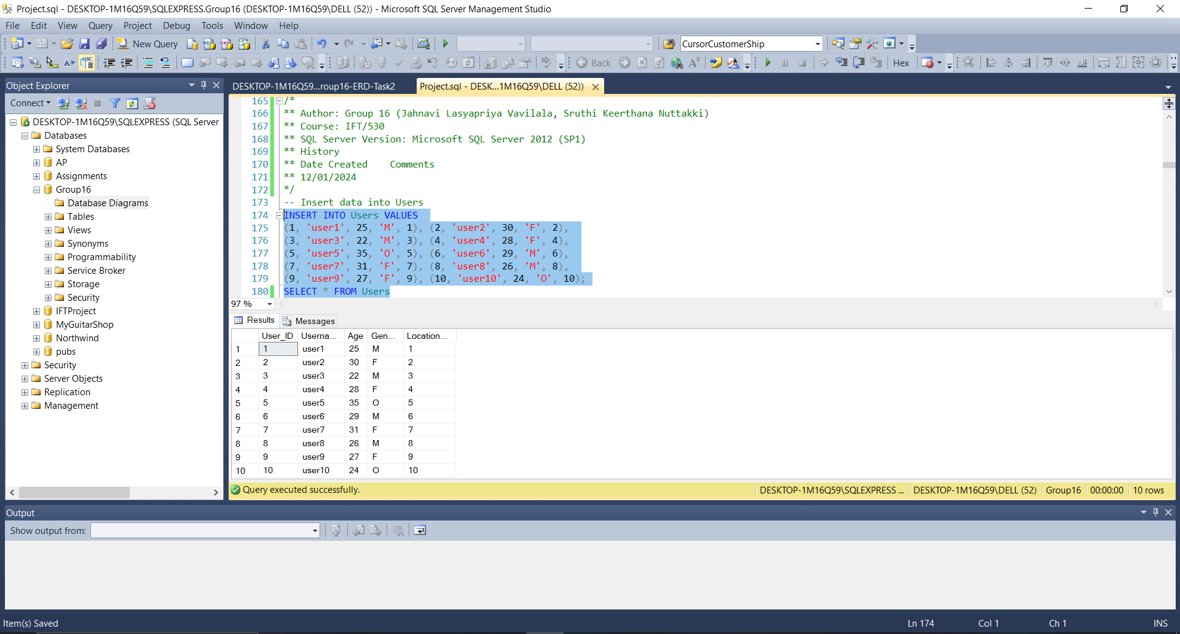

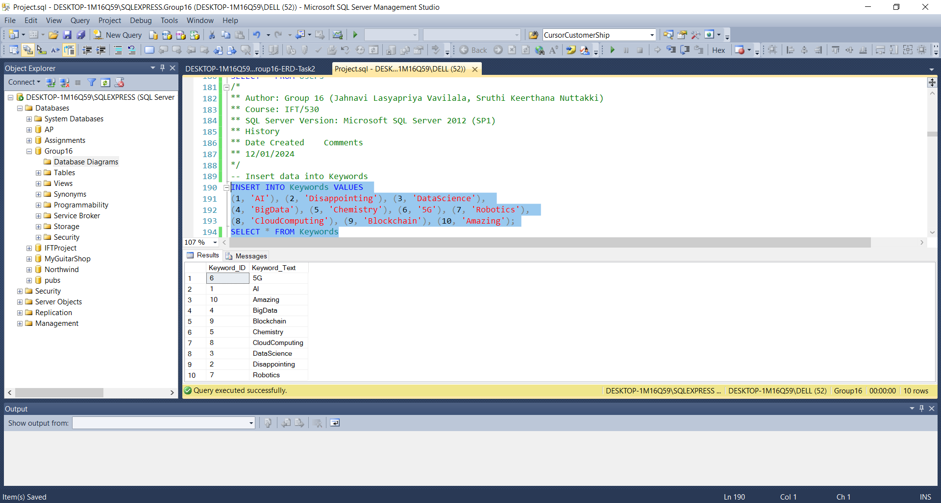

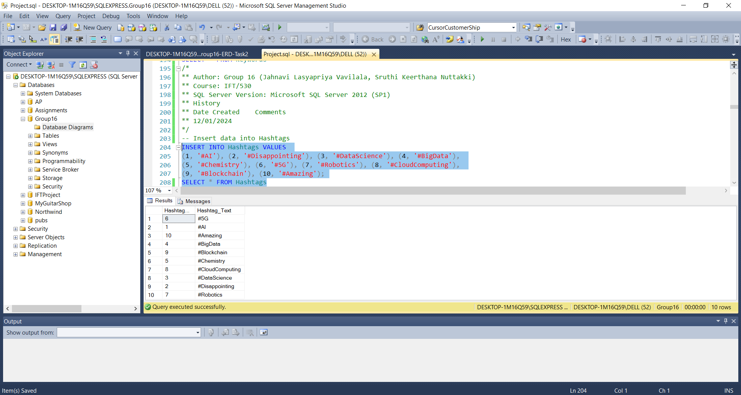

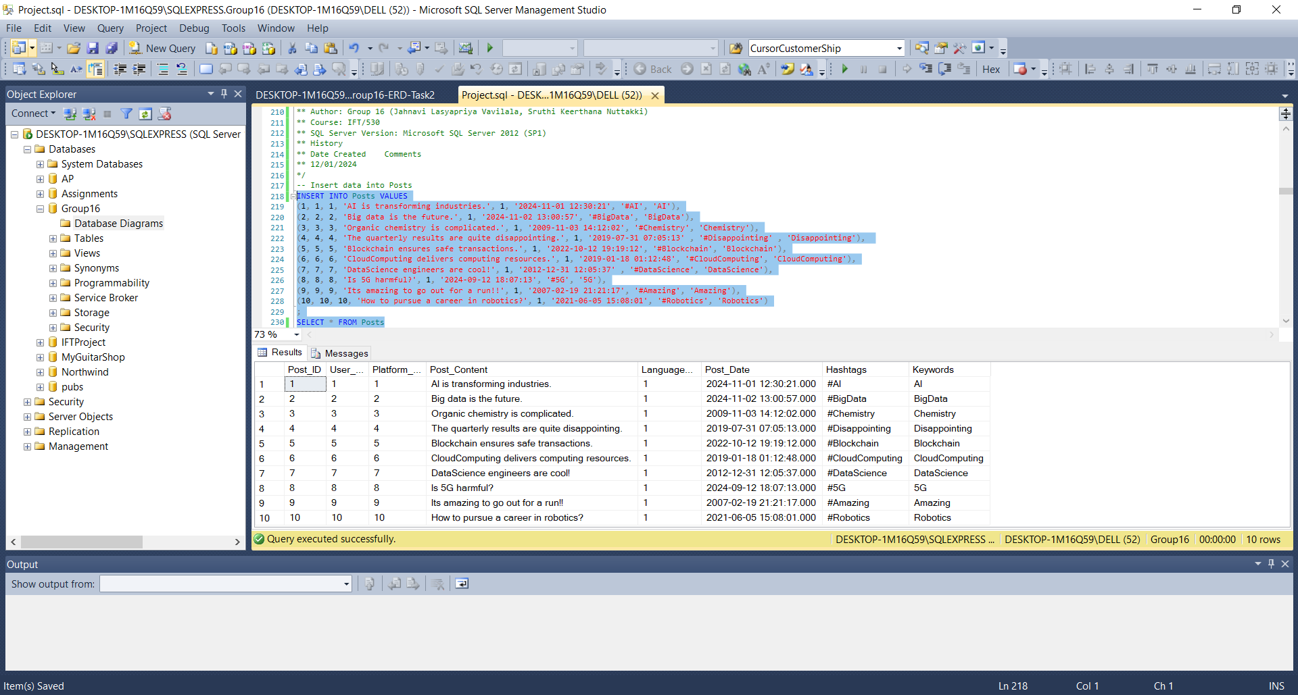

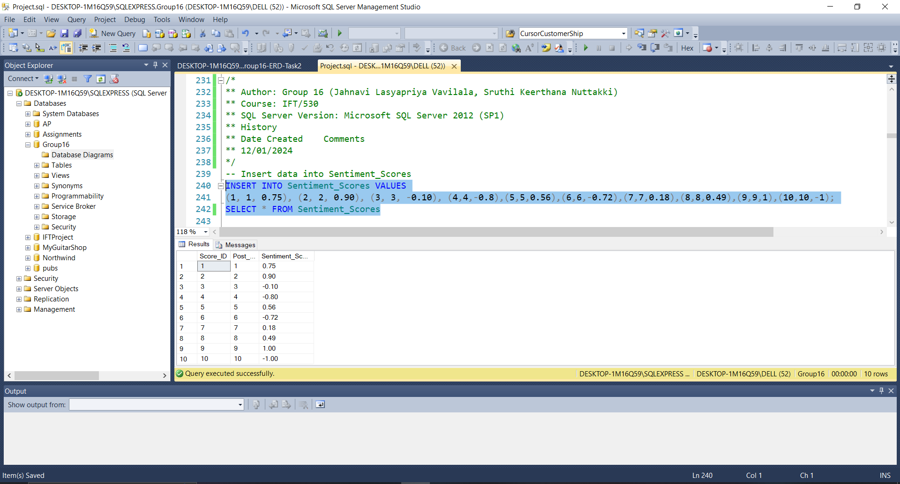

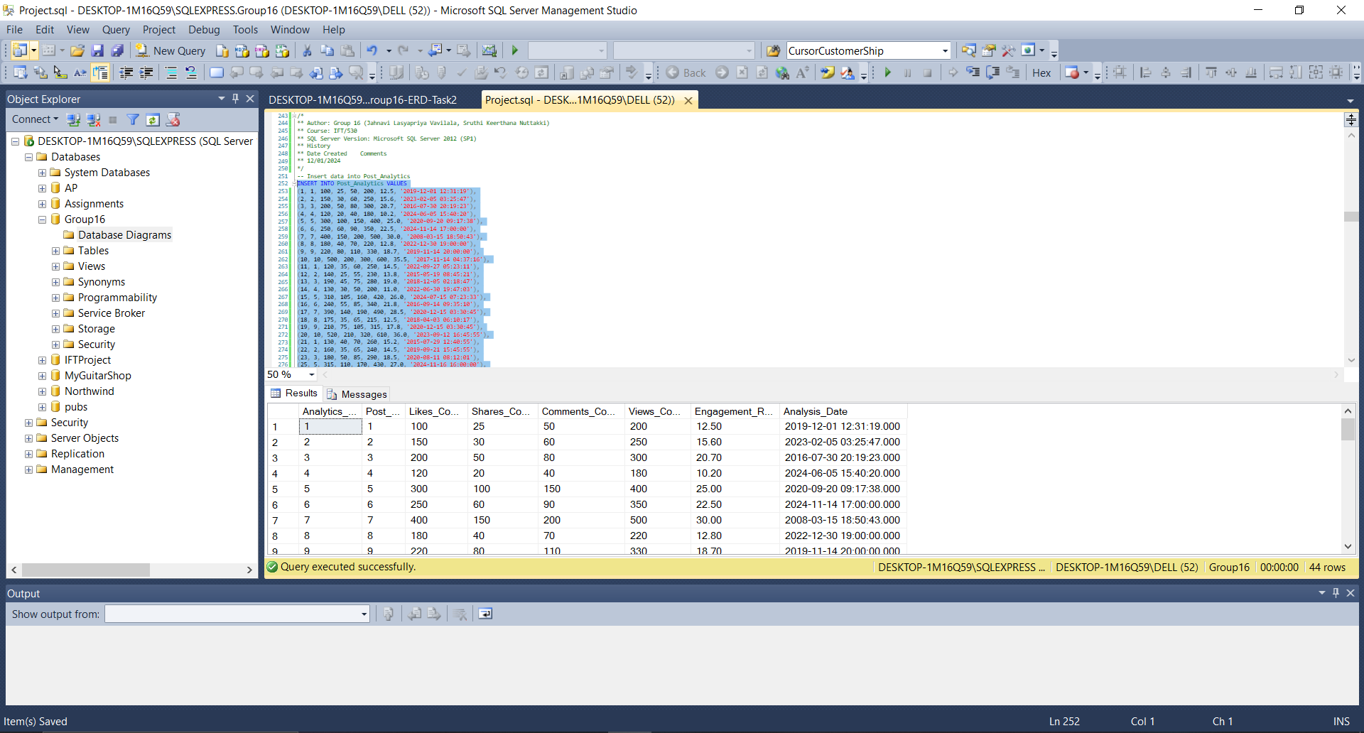

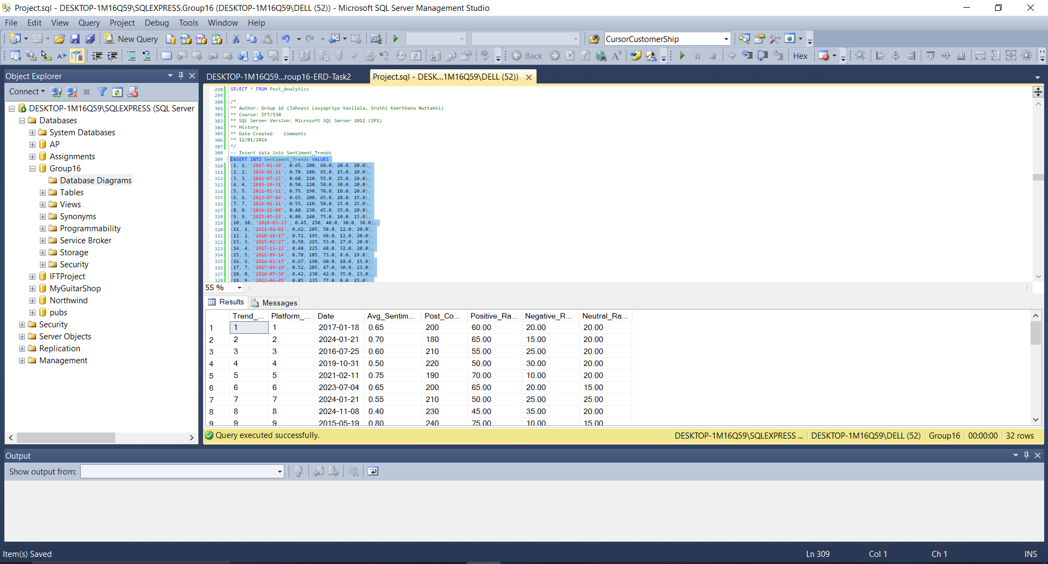

The entire code for populating the tables is as follows:

/*

** Author: Group 16 (Jahnavi Lasyapriya Vavilala, Sruthi Keerthana Nuttakki)

** Course: IFT/530

** SQL Server Version: Microsoft SQL Server 2012 (SP1)

** History

** Date Created Comments

** 12/01/2024

*/

-- Task 3

-- Insert data into Locations

INSERT INTO Locations VALUES (1, 'Phoenix'), (2, 'San Francisco'), (3, 'London'),

(4, 'Berlin'), (5, 'Tokyo'), (6, 'Hyderabad'), (7, 'Sydney'),

(8, 'Toronto'), (9, 'Dubai'), (10, 'Bengaluru');

SELECT * FROM Locations

/*

** Author: Group 16 (Jahnavi Lasyapriya Vavilala, Sruthi Keerthana Nuttakki)

** Course: IFT/530

** SQL Server Version: Microsoft SQL Server 2012 (SP1)

** History

** Date Created Comments

** 12/01/2024

*/

-- Insert data into Platforms

INSERT INTO Platforms VALUES (1, 'Twitter'), (2, 'Facebook'), (3, 'Instagram'),

(4, 'LinkedIn'), (5, 'YouTube'), (6,'Snapchat'),(7,'TikTok'),(8,'Reddit'),

(9,'Telegram'),(10,'Quora');

SELECT * FROM Platforms

/*

** Author: Group 16 (Jahnavi Lasyapriya Vavilala, Sruthi Keerthana Nuttakki)

** Course: IFT/530

** SQL Server Version: Microsoft SQL Server 2012 (SP1)

** History

** Date Created Comments

** 12/01/2024

*/

-- Insert data into Languages

INSERT INTO Languages VALUES (1, 'English'), (2, 'Telugu'), (3, 'French'),

(4, 'German'), (5, 'Japanese'), (6, 'Mandarin'),

(7, 'Hindi'), (8, 'Kannada'), (9, 'Portuguese'),

(10, 'Russian');

SELECT * FROM Languages

/*

** Author: Group 16 (Jahnavi Lasyapriya Vavilala, Sruthi Keerthana Nuttakki)

** Course: IFT/530

** SQL Server Version: Microsoft SQL Server 2012 (SP1)

** History

** Date Created Comments

** 12/01/2024

*/

-- Insert data into Users

INSERT INTO Users VALUES

(1, 'user1', 25, 'M', 1), (2, 'user2', 30, 'F', 2),

(3, 'user3', 22, 'M', 3), (4, 'user4', 28, 'F', 4),

(5, 'user5', 35, 'O', 5), (6, 'user6', 29, 'M', 6),

(7, 'user7', 31, 'F', 7), (8, 'user8', 26, 'M', 8),

(9, 'user9', 27, 'F', 9), (10, 'user10', 24, 'O', 10);

SELECT * FROM Users

/*

** Author: Group 16 (Jahnavi Lasyapriya Vavilala, Sruthi Keerthana Nuttakki)

** Course: IFT/530

** SQL Server Version: Microsoft SQL Server 2012 (SP1)

** History

** Date Created Comments

** 12/01/2024

*/

-- Insert data into Keywords

INSERT INTO Keywords VALUES

(1, 'AI'), (2, 'Disappointing'), (3, 'DataScience'),

(4, 'BigData'), (5, 'Chemistry'), (6, '5G'), (7, 'Robotics'),

(8, 'CloudComputing'), (9, 'Blockchain'), (10, 'Amazing');

SELECT * FROM Keywords

/*

** Author: Group 16 (Jahnavi Lasyapriya Vavilala, Sruthi Keerthana Nuttakki)

** Course: IFT/530

** SQL Server Version: Microsoft SQL Server 2012 (SP1)

** History

** Date Created Comments

** 12/01/2024

*/

-- Insert data into Hashtags

INSERT INTO Hashtags VALUES

(1, '#AI'), (2, '#Disappointing'), (3, '#DataScience'), (4, '#BigData'),

(5, '#Chemistry'), (6, '#5G'), (7, '#Robotics'), (8, '#CloudComputing'),

(9, '#Blockchain'), (10, '#Amazing');

SELECT * FROM Hashtags

/*

** Author: Group 16 (Jahnavi Lasyapriya Vavilala, Sruthi Keerthana Nuttakki)

** Course: IFT/530

** SQL Server Version: Microsoft SQL Server 2012 (SP1)

** History

** Date Created Comments

** 12/01/2024

*/

-- Insert data into Posts

INSERT INTO Posts VALUES

(1, 1, 1, 'AI is transforming industries.', 1, '2024-11-01 12:30:21', '#AI', 'AI'),

(2, 2, 2, 'Big data is the future.', 1, '2024-11-02 13:00:57', '#BigData', 'BigData'),

(3, 3, 3, 'Organic chemistry is complicated.', 1, '2009-11-03 14:12:02', '#Chemistry', 'Chemistry'),

(4, 4, 4, 'The quarterly results are quite disappointing.', 1, '2019-07-31 07:05:13' , '#Disappointing' , 'Disappointing'),

(5, 5, 5, 'Blockchain ensures safe transactions.', 1, '2022-10-12 19:19:12', '#Blockchain', 'Blockchain'),

(6, 6, 6, 'CloudComputing delivers computing resources.', 1, '2019-01-18 01:12:48', '#CloudComputing', 'CloudComputing'),

(7, 7, 7, 'DataScience engineers are cool!', 1, '2012-12-31 12:05:37' , '#DataScience', 'DataScience'),

(8, 8, 8, 'Is 5G harmful?', 1, '2024-09-12 18:07:13', '#5G', '5G'),

(9, 9, 9, 'Its amazing to go out for a run!!', 1, '2007-02-19 21:21:17', '#Amazing', 'Amazing'),

(10, 10, 10, 'How to pursue a career in robotics?', 1, '2021-06-05 15:08:01', '#Robotics', 'Robotics')

;

SELECT * FROM Posts

/*

** Author: Group 16 (Jahnavi Lasyapriya Vavilala, Sruthi Keerthana Nuttakki)

** Course: IFT/530

** SQL Server Version: Microsoft SQL Server 2012 (SP1)

** History

** Date Created Comments

** 12/01/2024

*/

-- Insert data into Sentiment_Scores

INSERT INTO Sentiment_Scores VALUES

(1, 1, 0.75), (2, 2, 0.90), (3, 3, -0.10), (4,4,-0.8),(5,5,0.56),(6,6,-0.72),(7,7,0.18),(8,8,0.49),(9,9,1),(10,10,-1);

SELECT * FROM Sentiment_Scores

/*

** Author: Group 16 (Jahnavi Lasyapriya Vavilala, Sruthi Keerthana Nuttakki)

** Course: IFT/530

** SQL Server Version: Microsoft SQL Server 2012 (SP1)

** History

** Date Created Comments

** 12/01/2024

*/

-- Insert data into Post_Analytics

INSERT INTO Post_Analytics VALUES

(1, 1, 100, 25, 50, 200, 12.5, '2019-12-01 12:31:19'),

(2, 2, 150, 30, 60, 250, 15.6, '2023-02-05 03:25:47'),

(3, 3, 200, 50, 80, 300, 20.7, '2016-07-30 20:19:23'),

(4, 4, 120, 20, 40, 180, 10.2, '2024-06-05 15:40:20'),

(5, 5, 300, 100, 150, 400, 25.0, '2020-09-20 09:17:38'),

(6, 6, 250, 60, 90, 350, 22.5, '2024-11-14 17:00:00'),

(7, 7, 400, 150, 200, 500, 30.0, '2008-03-15 18:50:43'),

(8, 8, 180, 40, 70, 220, 12.8, '2022-12-30 19:00:00'),

(9, 9, 220, 80, 110, 330, 18.7, '2019-11-14 20:00:00'),

(10, 10, 500, 200, 300, 600, 35.5, '2017-11-14 04:37:16'),

(11, 1, 120, 35, 60, 250, 14.5, '2022-09-27 05:23:11'),

(12, 2, 140, 25, 55, 230, 13.8, '2015-05-19 08:45:21'),

(13, 3, 190, 45, 75, 280, 19.0, '2018-12-05 02:18:47'),

(14, 4, 130, 30, 50, 200, 11.0, '2022-06-30 19:47:03'),

(15, 5, 310, 105, 160, 420, 26.0, '2024-07-15 07:23:33'),

(16, 6, 240, 55, 85, 340, 21.8, '2016-09-14 09:35:10'),

(17, 7, 390, 140, 190, 490, 28.5, '2020-12-15 03:30:45'),

(18, 8, 175, 35, 65, 215, 12.5, '2018-04-03 06:10:17'),

(19, 9, 210, 75, 105, 315, 17.8, '2020-12-15 03:30:45'),

(20, 10, 520, 210, 320, 610, 36.0, '2023-09-12 16:45:55'),

(21, 1, 130, 40, 70, 260, 15.2, '2015-07-29 12:40:55'),

(22, 2, 160, 35, 65, 240, 14.5, '2019-09-21 15:45:55'),

(23, 3, 180, 50, 85, 290, 18.5, '2020-08-11 08:12:01'),

(25, 5, 315, 110, 170, 430, 27.0, '2024-11-16 16:00:00'),

(26, 6, 230, 50, 80, 330, 21.0, '2022-02-28 20:12:39'),

(27, 7, 410, 160, 210, 510, 29.0, '2020-04-15 22:14:37'),

(28, 8, 165, 30, 60, 205, 11.8, '2020-11-19 19:10:04'),

(29, 9, 225, 85, 115, 325, 19.0, '2023-07-04 17:35:47'),

(30, 10, 510, 195, 305, 620, 37.2, '2017-08-15 13:40:55'),

(31, 1, 140, 45, 75, 270, 16.0, '2020-10-17 16:00:31'),

(32, 2, 150, 40, 70, 250, 15.0, '2017-11-22 22:59:45'),

(33, 3, 175, 55, 90, 300, 17.5, '2022-02-28 20:12:39'),

(34, 4, 135, 35, 55, 210, 12.0, '2024-03-15 17:30:027'),

(35, 5, 320, 115, 175, 440, 28.0, '2018-12-04 05:06:43'),

(36, 6, 220, 45, 75, 320, 20.0, '2024-11-17 17:00:00'),

(37, 7, 405, 155, 205, 520, 29.5, '2016-03-30 17:13:08'),

(38, 8, 170, 35, 65, 215, 12.2, '2019-01-15 02:34:57'),

(39, 9, 220, 80, 110, 335, 18.2, '2023-05-20 09:55:27'),

(40, 10, 515, 200, 310, 630, 36.5, '2018-12-05 02:18:47'),

(41, 1, 120, 35, 65, 240, 14.5, '2015-12-26 12:15:35'),

(42, 2, 145, 30, 60, 220, 13.5, '2020-10-17 16:00:31'),

(43, 3, 170, 50, 85, 280, 18.0, '2023-04-10 21:45:55'),

(44, 4, 125, 25, 45, 190, 10.5, '2019-07-11 09:31:07'),

(45, 5, 310, 105, 165, 420, 26.0, '2021-01-01 11:11:11');

;

SELECT * FROM Post_Analytics

/*

** Author: Group 16 (Jahnavi Lasyapriya Vavilala, Sruthi Keerthana Nuttakki)

** Course: IFT/530

** SQL Server Version: Microsoft SQL Server 2012 (SP1)

** History

** Date Created Comments

** 12/01/2024

*/

-- Insert data into Sentiment_Trends

INSERT INTO Sentiment_Trends VALUES

(1, 1, '2017-01-18', 0.65, 200, 60.0, 20.0, 20.0),

(2, 2, '2024-01-21', 0.70, 180, 65.0, 15.0, 20.0),

(3, 3, '2016-07-25', 0.60, 210, 55.0, 25.0, 20.0),

(4, 4, '2019-10-31', 0.50, 220, 50.0, 30.0, 20.0),

(5, 5, '2021-02-11', 0.75, 190, 70.0, 10.0, 20.0),

(6, 6, '2023-07-04', 0.65, 200, 65.0, 20.0, 15.0),

(7, 7, '2024-01-21', 0.55, 210, 50.0, 25.0, 25.0),

(8, 8, '2024-11-08', 0.40, 230, 45.0, 35.0, 20.0),

(9, 9, '2015-05-19', 0.80, 240, 75.0, 10.0, 15.0),

(10, 10, '2019-03-23', 0.45, 250, 40.0, 30.0, 30.0),

(11, 1, '2021-01-01', 0.62, 205, 58.0, 22.0, 20.0),

(12, 2, '2020-10-17', 0.72, 195, 68.0, 12.0, 20.0),

(13, 3, '2015-02-27', 0.58, 215, 53.0, 27.0, 20.0),

(14, 4, '2017-11-22', 0.48, 225, 48.0, 32.0, 20.0),

(15, 5, '2016-09-14', 0.78, 185, 73.0, 8.0, 19.0),

(16, 6, '2024-03-15', 0.67, 190, 60.0, 18.0, 15.0),

(17, 7, '2017-09-20', 0.52, 205, 47.0, 30.0, 23.0),

(18, 8, '2020-07-30', 0.42, 230, 42.0, 35.0, 23.0),

(19, 9, '2022-06-05', 0.85, 235, 77.0, 8.0, 15.0),

(20, 10, '2015-03-31', 0.49, 245, 45.0, 30.0, 25.0),

(21, 1, '2021-11-21', 0.65, 210, 58.0, 20.0, 22.0),

(22, 2, '2020-12-17', 0.75, 200, 68.0, 10.0, 22.0),

(23, 3, '2017-05-27', 0.63, 215, 55.0, 25.0, 20.0),

(24, 4, '2015-07-29', 0.52, 220, 50.0, 30.0, 22.0),

(25, 5, '2024-09-14', 0.77, 180, 70.0, 8.0, 18.0),

(26, 6, '2017-11-19', 0.66, 190, 62.0, 18.0, 14.0),

(27, 7, '2022-09-20', 0.53, 210, 49.0, 29.0, 24.0),

(28, 8, '2016-04-03', 0.44, 225, 44.0, 35.0, 24.0),

(29, 9, '2018-01-29', 0.88, 235, 78.0, 7.0, 14.0),

(30, 10, '2024-11-30', 0.46, 240, 43.0, 29.0, 26.0),

(31, 1, '2015-08-09', 0.68, 215, 60.0, 22.0, 23.0),

(32, 2, '2023-12-27', 0.73, 205, 69.0, 11.0, 23.0)

SELECT * FROM Sentiment_Trends;

**Task 4: Create three queries and convert them into views. Explain why you think would be useful to the user. All queries must be joined to one or more tables. Make sure you restrict the data by using a where clause for each of the queries.**

**View 1: Positive Sentiment Posts by Platform**

Purpose: This view lists posts with positive sentiment scores (Sentiment_Score > 0.5) for each platform. It helps businesses identify which platforms host the most positive content, enabling targeted engagement strategies and campaign optimization.

**Code:**

/*

** Author: Group 16 (Jahnavi Lasyapriya Vavilala, Sruthi Keerthana Nuttakki)

** Course: IFT/530

** SQL Server Version: Microsoft SQL Server 2012 (SP1)

** History

** Date Created Comments

** 12/01/2024

*/

--Task 4

--Query for View 1, Positive Sentiment Posts by Platform, Explanation: This view lists posts with positive sentiment scores (Sentiment_Score > 0.5) for each platform.

CREATE VIEW Positive_Posts_By_Platform AS

SELECT

ps.Post_ID,

p.Platform_Name,

ps.Post_Content,

ss.Sentiment_Score

FROM

Posts ps

JOIN

Platforms p ON ps.Platform_ID = p.Platform_ID

JOIN

Sentiment_Scores ss ON ps.Post_ID = ss.Post_ID

WHERE

ss.Sentiment_Score > 0.5; -- Restricting to positive sentiment

SELECT * FROM Positive_Posts_By_Platform;

**Screenshot with results:**

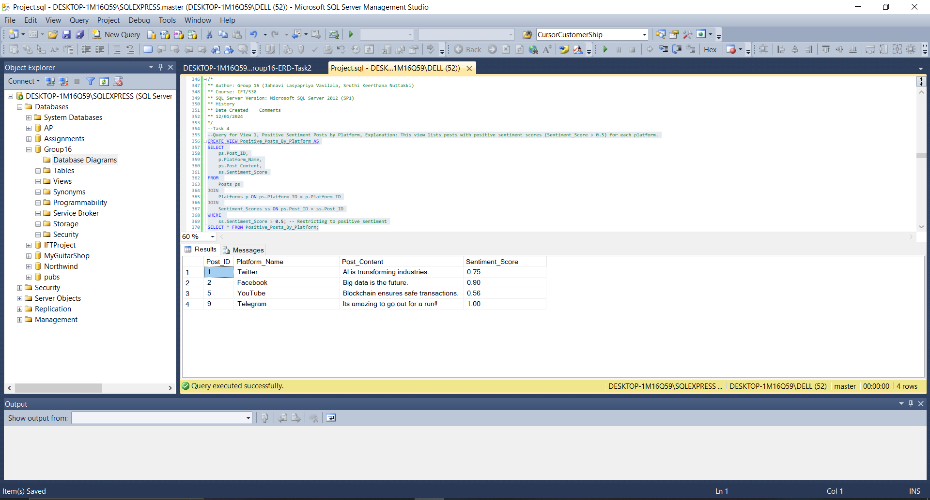

**View 2: Active Users with High Engagement**

Purpose: This view identifies users whose posts have high engagement rates (Engagement_Rate > 10.0). It can be used to recognize and target active or influential users for partnerships or deeper engagement strategies.

**Code:**

/*

** Author: Group 16 (Jahnavi Lasyapriya Vavilala, Sruthi Keerthana Nuttakki)

** Course: IFT/530

** SQL Server Version: Microsoft SQL Server 2012 (SP1)

** History

** Date Created Comments

** 12/01/2024

*/

--Query for View 2, Active Users with High Engagement, Explanation: This view identifies users whose posts have high engagement rates (Engagement_Rate > 10.0)

CREATE VIEW Active_Users_With_Engagement AS

SELECT

u.Username,

SUM(pa.Likes_Count) AS Total_Likes,

SUM(pa.Shares_Count) AS Total_Shares,

SUM(pa.Comments_Count) AS Total_Comments

FROM

Users u

JOIN

Posts ps ON u.User_ID = ps.User_ID

JOIN

Post_Analytics pa ON ps.Post_ID = pa.Post_ID

WHERE

pa.Engagement_Rate > 10.0 -- Restricting to high engagement posts

GROUP BY

u.Username;

SELECT * FROM Active_Users_With_Engagement;

GO;

**Screenshot with Results:**

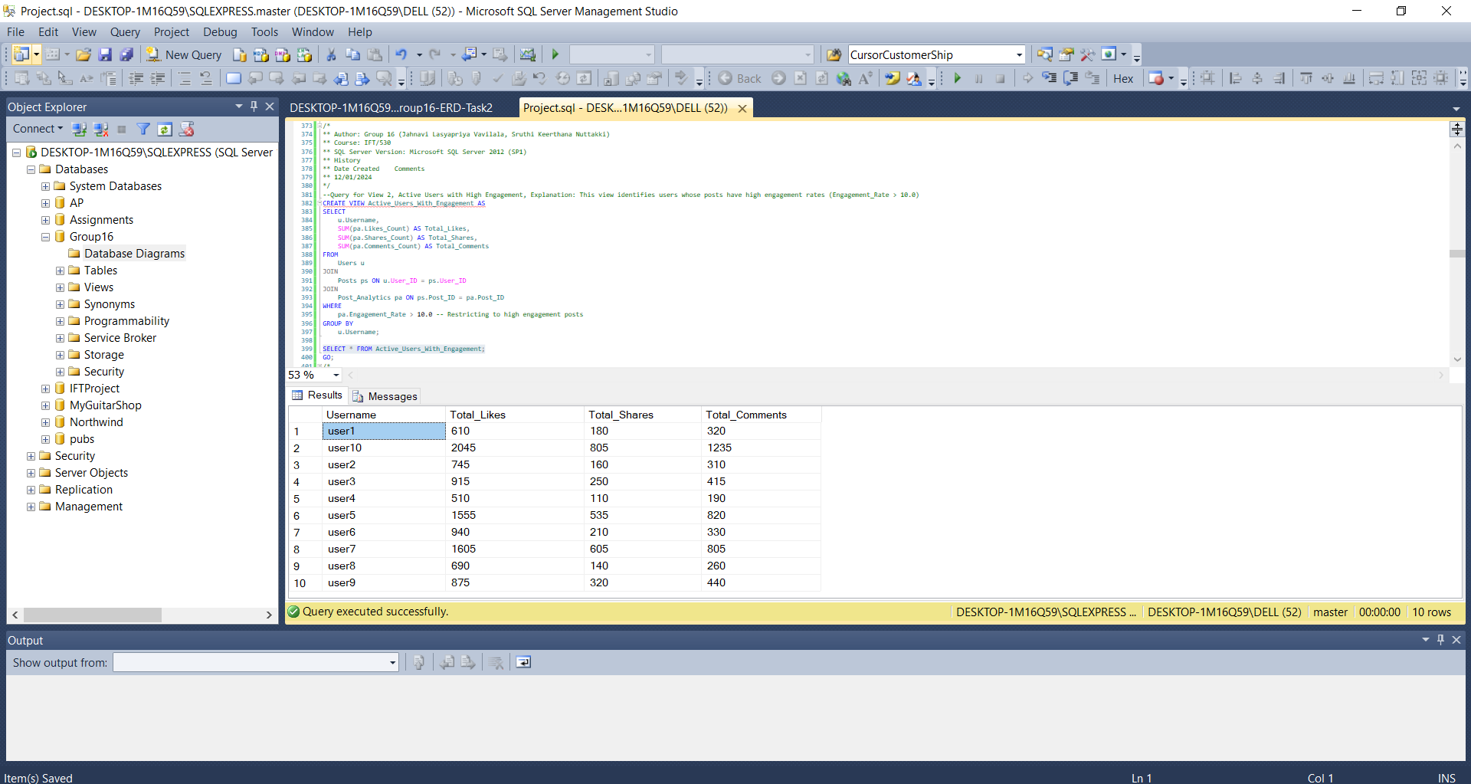

**View 3: Active_User_Insights**

Purpose: The Active_User_Insights view highlights the activity of users who have posted within the last year. It combines information from multiple tables to display the username, location, total number of posts, average sentiment score, and the maximum views for any of their posts. This view is particularly useful for identifying active and influential users across different locations, providing actionable insights into user engagement and sentiment trends.

**Code:**

/*

** Author: Group 16 (Jahnavi Lasyapriya Vavilala, Sruthi Keerthana Nuttakki)

** Course: IFT/530

** SQL Server Version: Microsoft SQL Server 2012 (SP1)

** History

** Date Created Comments

** 12/01/2024

*/

--Query for View 3, Active_User_Insights, Explanation:This view provides insights into user activity by showing their total posts, average sentiment score, and maximum views on any post.

CREATE VIEW Active_User_Insights AS

SELECT

u.Username,

l.Location_Name,

COUNT(p.Post_ID) AS Total_Posts,

AVG(ss.Sentiment_Score) AS Avg_Sentiment,

MAX(pa.Views_Count) AS Max_Views

FROM

Users u

JOIN

Posts p ON u.User_ID = p.User_ID

JOIN

Locations l ON u.Location_ID = l.Location_ID

JOIN

Sentiment_Scores ss ON p.Post_ID = ss.Post_ID

JOIN

Post_Analytics pa ON p.Post_ID = pa.Post_ID

WHERE

p.Post_Date >= DATEADD(YEAR, -1, GETDATE())

GROUP BY

u.Username, l.Location_Name;

SELECT * FROM Active_User_Insights

GO

**Screenshot with results:**

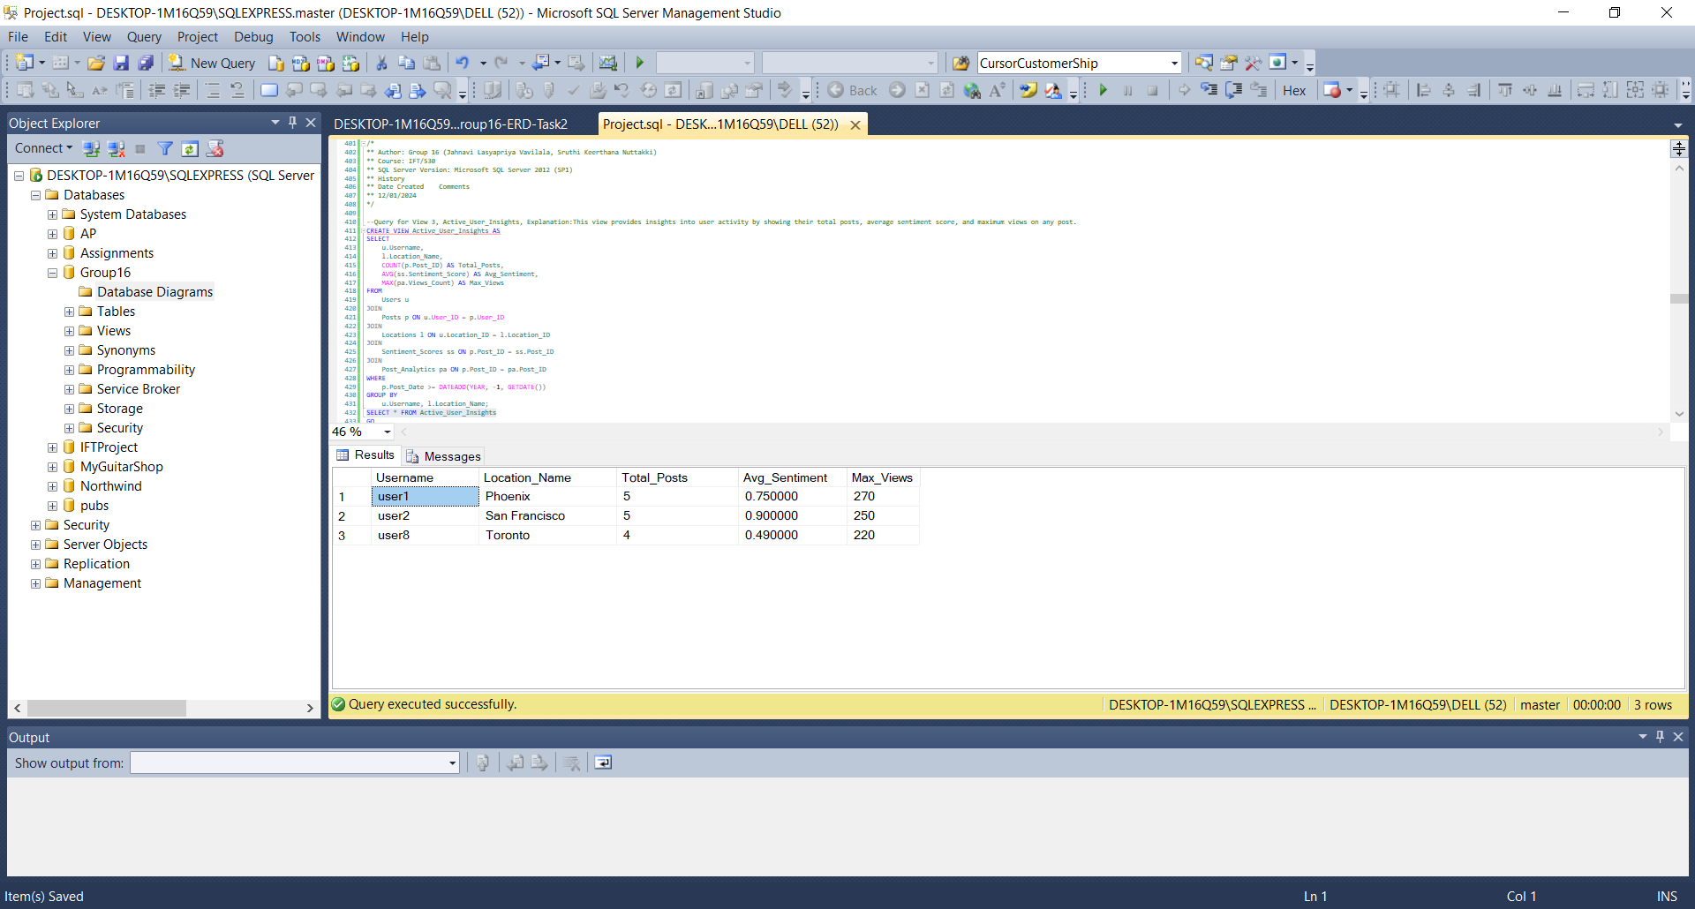

**Task 5: Create an audit table for one of the lookup tables and demonstrate data saved to that audit table when data in the original table is inserted, modified, or deleted. Include an additional column in the audit table that will have a datetime field when the data was changed in the original table. Include the script to test all the operations.**

**Objective:**

The purpose of this task is to create an audit table for the Hashtags table, which tracks the INSERT, UPDATE, and DELETE operations performed on the original table. Additionally, the audit table will include a Change_Timestamp column that records the date and time when each change occurred.

**Code:**

/*

** Author: Group 16 (Jahnavi Lasyapriya Vavilala, Sruthi Keerthana Nuttakki)

** Course: IFT/530

** SQL Server Version: Microsoft SQL Server 2012 (SP1)

** History

** Date Created Comments

** 12/01/2024

*/

-- Step 1: Dropping the existing tables

IF OBJECT_ID('Hashtags_Audit', 'U') IS NOT NULL

DROP TABLE Hashtags_Audit;

GO

IF OBJECT_ID('Hashtags', 'U') IS NOT NULL

DROP TABLE Hashtags;

GO

-- Step 2: Create the Hashtags Table

CREATE TABLE Hashtags (

Hashtag_ID INT IDENTITY(1,1) NOT NULL PRIMARY KEY, -- Auto-incrementing ID

Hashtag_Text NVARCHAR(100) NOT NULL UNIQUE -- Unique hashtag text

);

GO

-- Step 3: Create the Hashtags_Audit Table

CREATE TABLE Hashtags_Audit (

Audit_ID INT IDENTITY(1,1) NOT NULL PRIMARY KEY, -- Unique identifier for each audit entry

Hashtag_ID INT NOT NULL, -- Reference to the original Hashtag_ID

Operation_Type NVARCHAR(10) NOT NULL, -- Type of operation: 'INSERT', 'UPDATE', 'DELETE'

Hashtag_Text NVARCHAR(100), -- The hashtag text being audited

Change_Timestamp DATETIME DEFAULT GETDATE() -- Timestamp of the operation

);

GO

-- Step 4: Create Triggers for the Hashtags Table

-- Trigger for INSERT Operations

CREATE TRIGGER trg_Hashtags_Insert

ON Hashtags

AFTER INSERT

AS

BEGIN

INSERT INTO Hashtags_Audit (Hashtag_ID, Operation_Type, Hashtag_Text, Change_Timestamp)

SELECT

inserted.Hashtag_ID,

'INSERT',

inserted.Hashtag_Text,

GETDATE()

FROM

inserted;

END;

GO

-- Trigger for UPDATE Operations

CREATE TRIGGER trg_Hashtags_Update

ON Hashtags

AFTER UPDATE

AS

BEGIN

INSERT INTO Hashtags_Audit (Hashtag_ID, Operation_Type, Hashtag_Text, Change_Timestamp)

SELECT

inserted.Hashtag_ID,

'UPDATE',

inserted.Hashtag_Text,

GETDATE()

FROM

inserted;

END;

GO

-- Trigger for DELETE Operations

CREATE TRIGGER trg_Hashtags_Delete

ON Hashtags

AFTER DELETE

AS

BEGIN

INSERT INTO Hashtags_Audit (Hashtag_ID, Operation_Type, Hashtag_Text, Change_Timestamp)

SELECT

deleted.Hashtag_ID,

'DELETE',

deleted.Hashtag_Text,

GETDATE()

FROM

deleted;

END;

GO

-- Step 5: Test the Triggers

-- Insert test data into Hashtags

INSERT INTO Hashtags (Hashtag_Text) VALUES

('#AI'),

('#BigData'),

('#CloudComputing');

GO

-- Check the audit table after insert

SELECT * FROM Hashtags_Audit;

GO

-- Update test data in the Hashtags table

UPDATE Hashtags

SET Hashtag_Text = '#ArtificialIntelligence'

WHERE Hashtag_ID = 1;

GO

-- Check the audit table after update

SELECT * FROM Hashtags_Audit;

GO

-- Delete test data from Hashtags table

DELETE FROM Hashtags

WHERE Hashtag_ID = 2;

GO

-- Check the audit table after delete

SELECT * FROM Hashtags_Audit;

GO

**5.1 Created Hashtag_Audits table:**

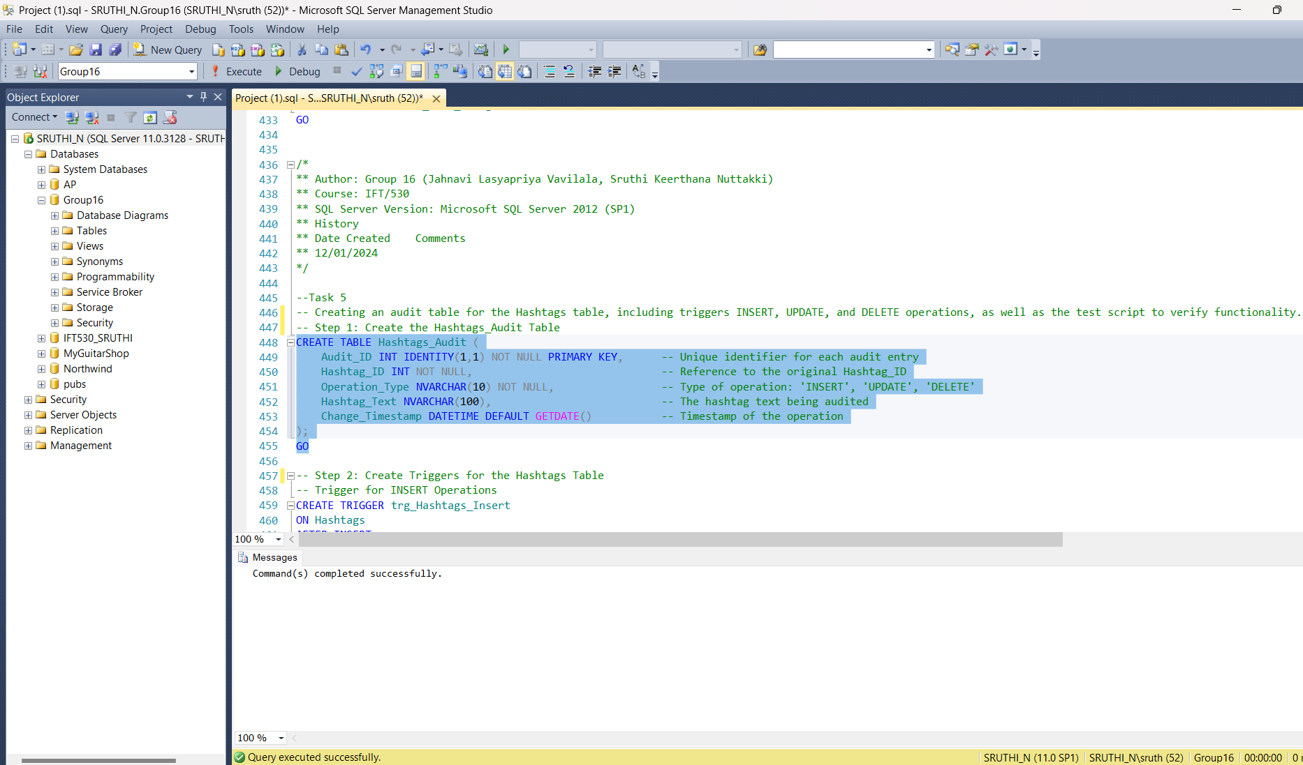

**5.2 Create Triggers for INSERT, UPDATE, DELETE Operations**

**Trigger for INSERT Operation**

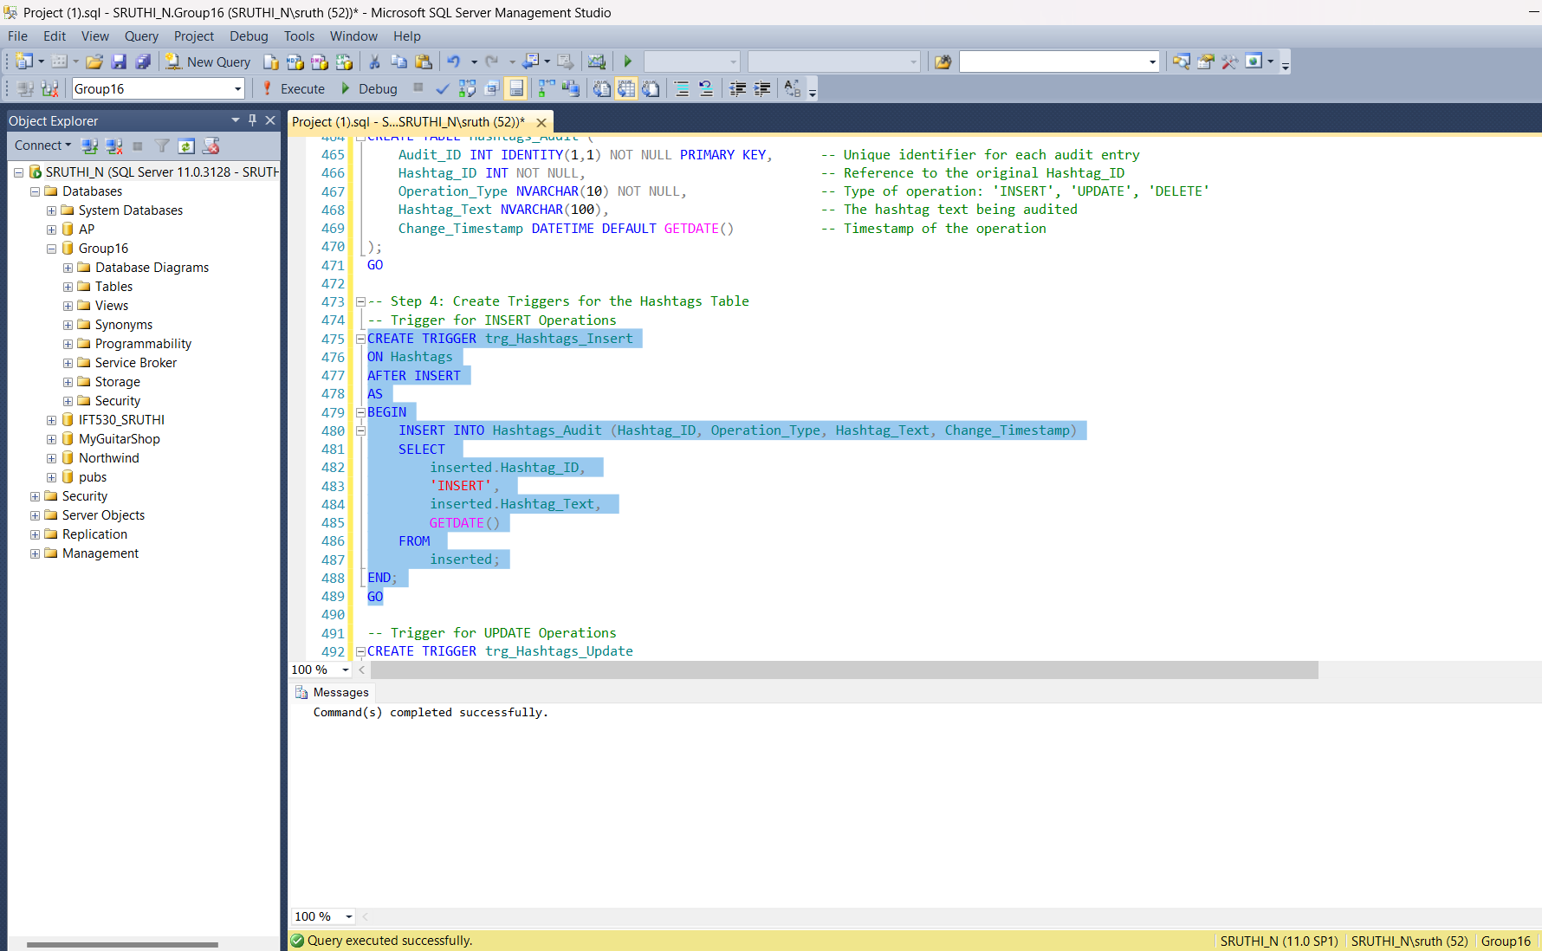

**Trigger for UPDATE Operation**

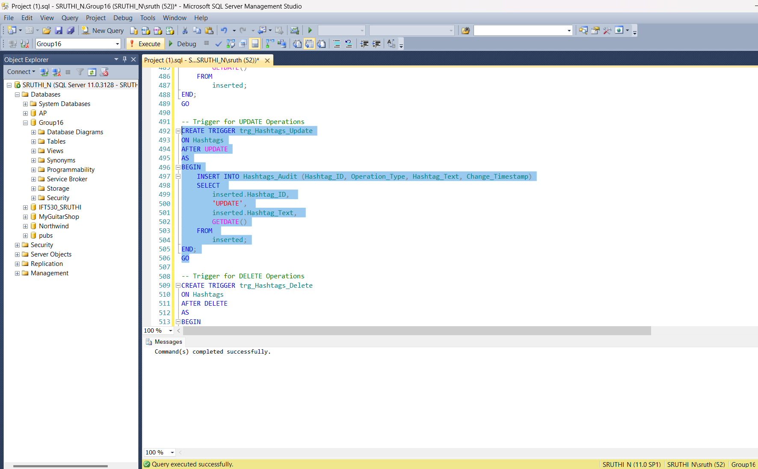

**Trigger for DELETE Operation**

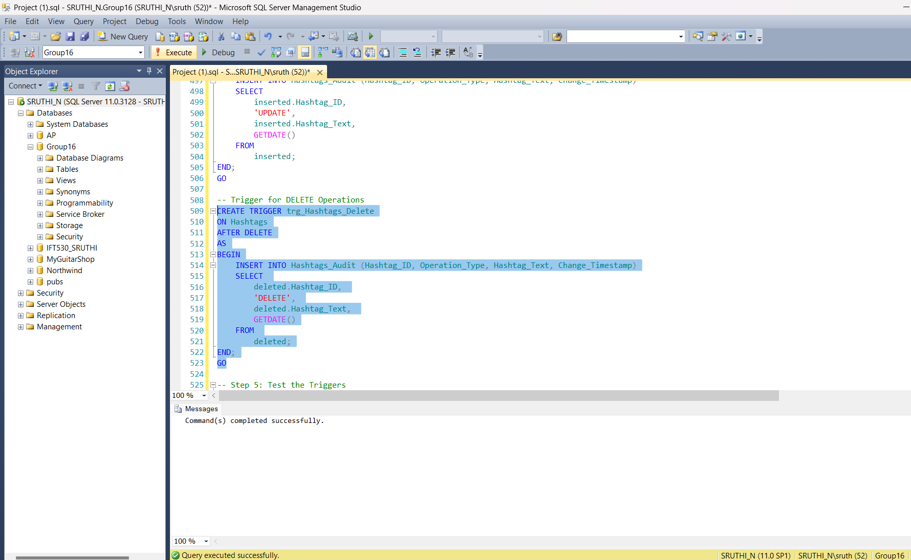

**5.3 Testing the triggers**

**Inserted the test data into Hashtags and checked the audit table after insertion.**

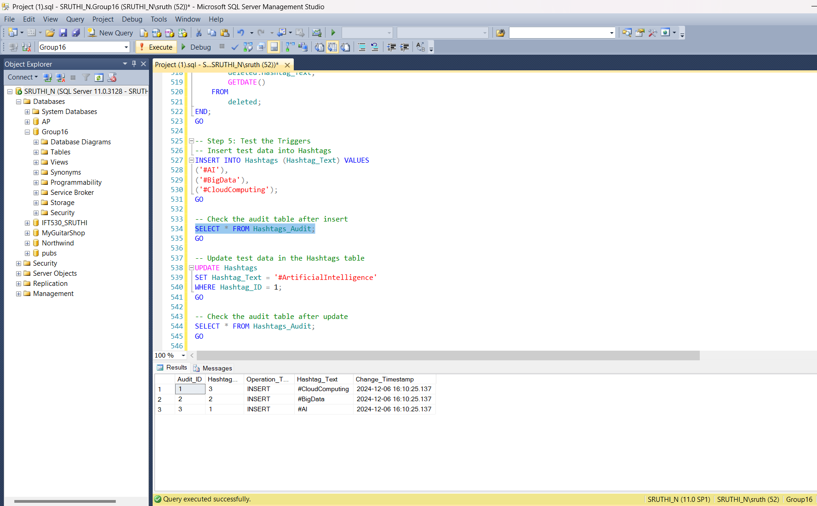

**Updated the test data in the Hashtags table and checked the audit table after the update.**

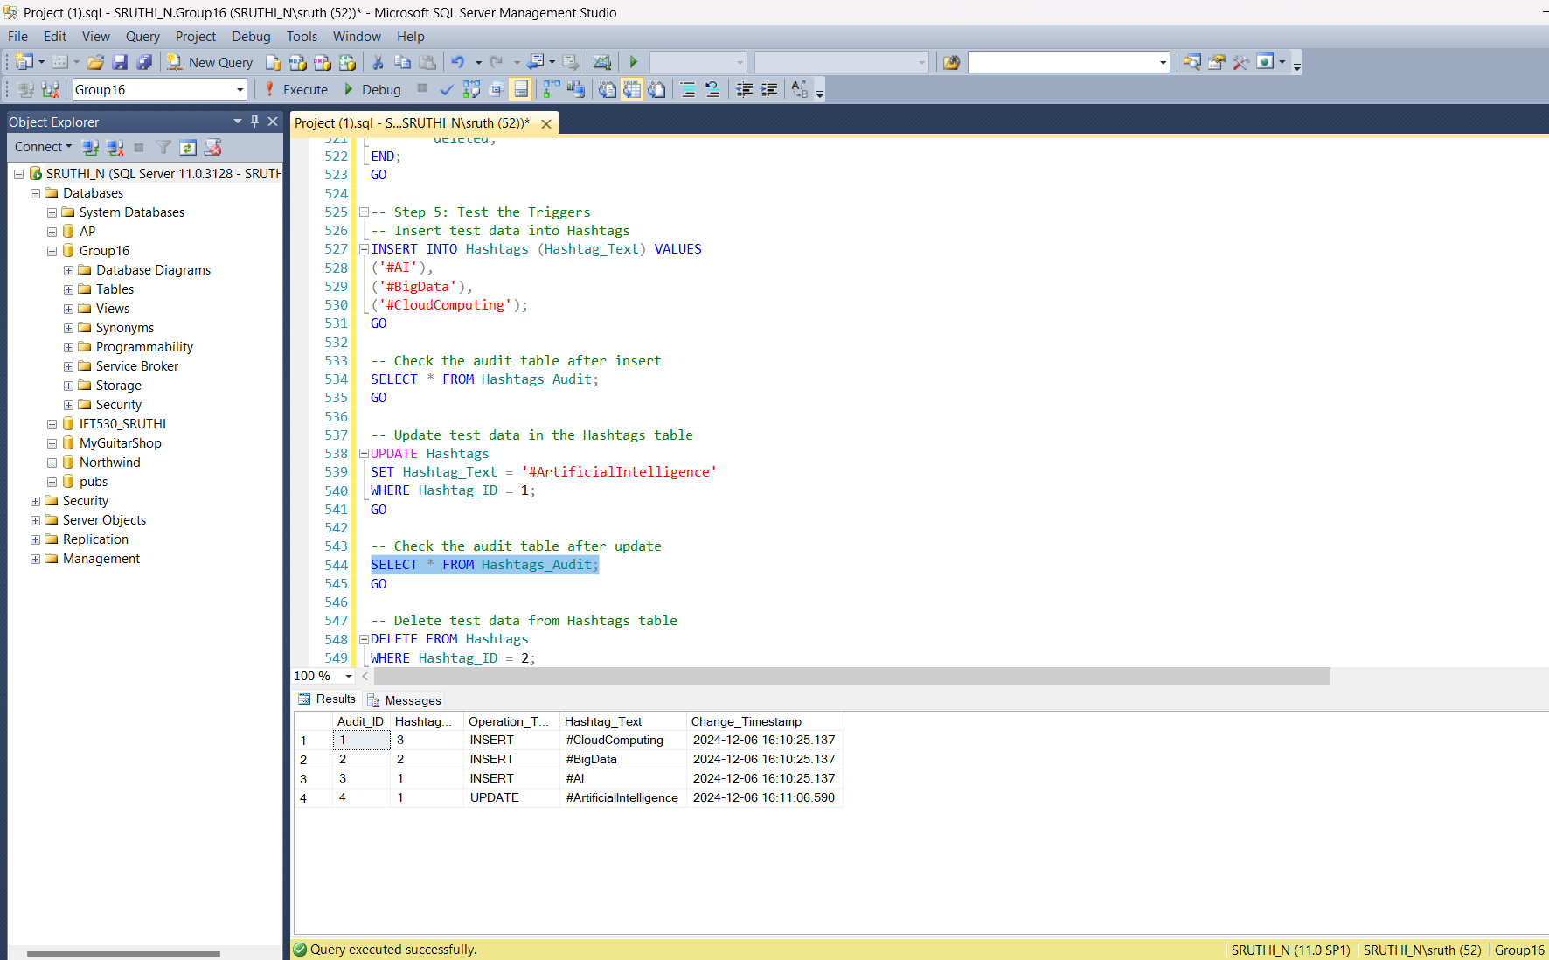

**Deleted the test data from the Hashtags table and checked the audit table after the deletion.**

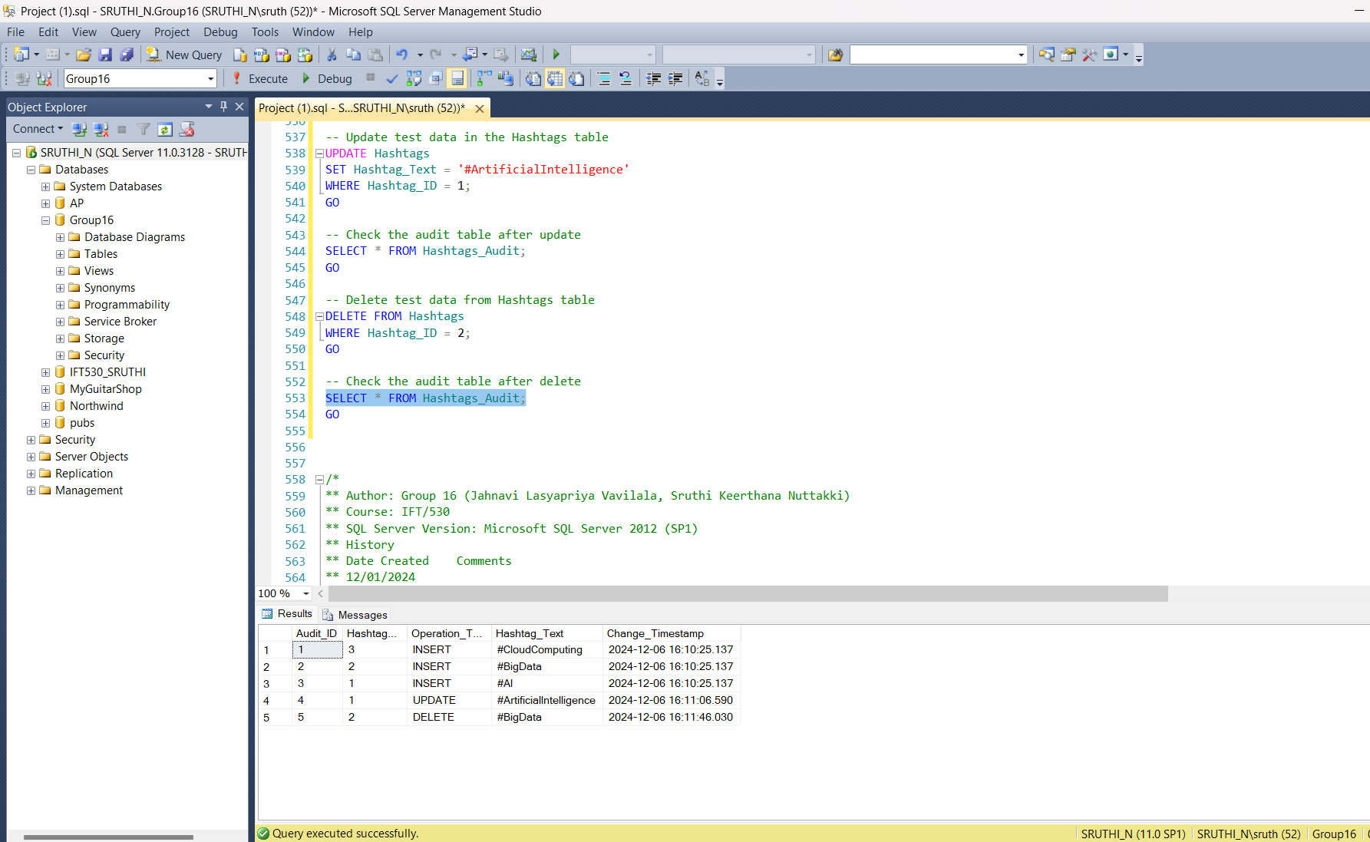

**Task 6: Demonstrate a use of the one stored procedures and User Defined Function (UDF) for your database. Include create and drop scripts.**

**6.1 Stored Procedure**

**Purpose:** A stored procedure to fetch all hashtags with a specified keyword in the Hashtag_Text.

**Code:**

/*

** Author: Group 16 (Jahnavi Lasyapriya Vavilala, Sruthi Keerthana Nuttakki)

** Course: IFT/530

** SQL Server Version: Microsoft SQL Server 2012 (SP1)

** History

** Date Created Comments

** 12/01/2024

*/

--1. Stored Procedure

--Purpose: A stored procedure to fetch all hashtags with a specified keyword in the Hashtag_Text.

--Create Stored Procedure:

-- Drop the stored procedure if it exists

IF OBJECT_ID('GetHashtagsByKeyword', 'P') IS NOT NULL

DROP PROCEDURE GetHashtagsByKeyword;

GO

-- Create the stored procedure

CREATE PROCEDURE GetHashtagsByKeyword

@Keyword NVARCHAR(50)

AS

BEGIN

SELECT Hashtag_ID, Hashtag_Text

FROM Hashtags

WHERE Hashtag_Text LIKE '%' + @Keyword + '%';

END;

GO

-- Example 1: Fetch hashtags containing 'AI'

EXEC GetHashtagsByKeyword @Keyword = 'CloudComputing';

-- Drop the stored procedure

DROP PROCEDURE GetHashtagsByKeyword;

GO

**Created the stored procedure.**

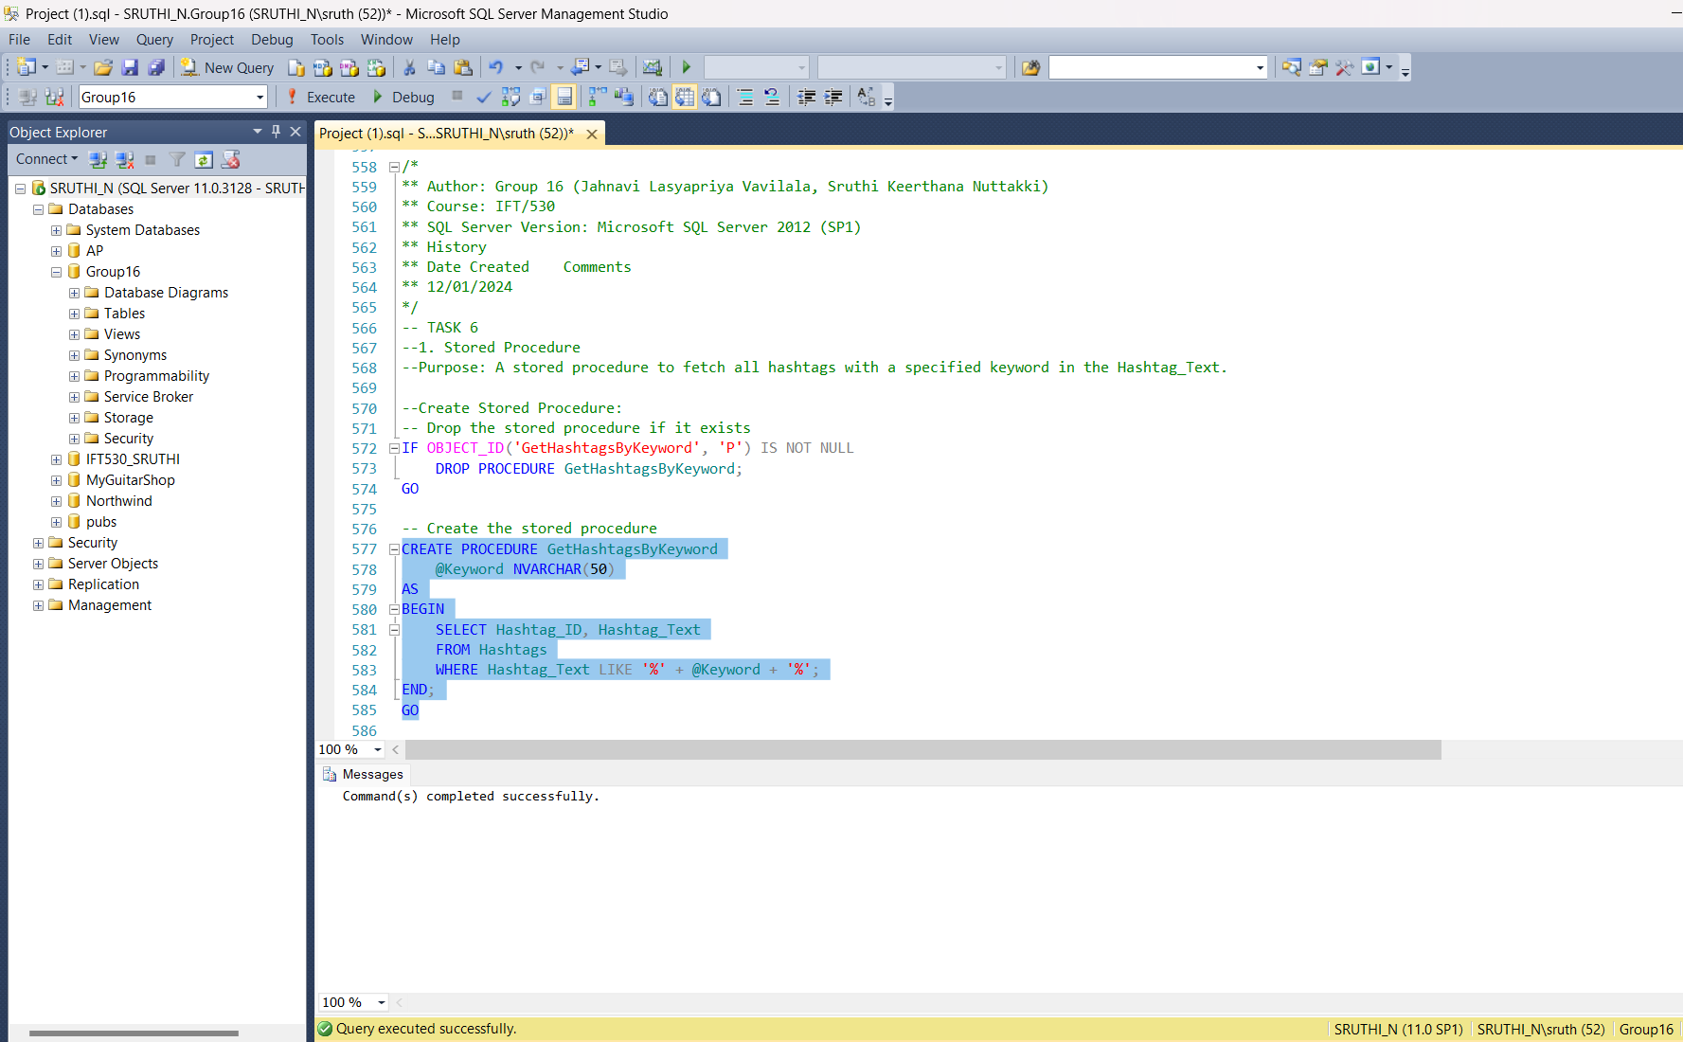

**Test case: Fetching hashtags containing ‘CloudComputing’**

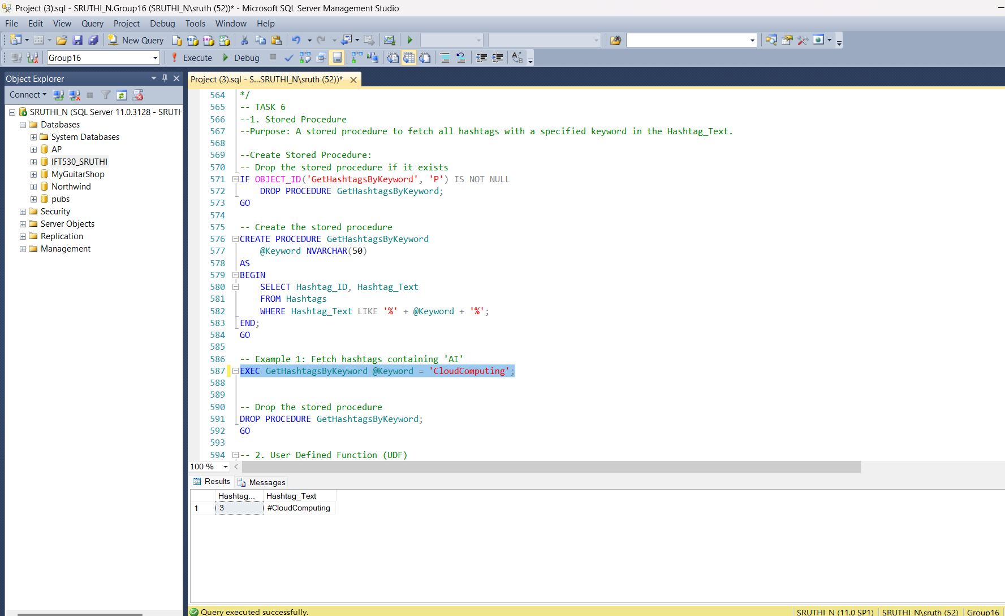

**Dropping the Stored Procedure.**

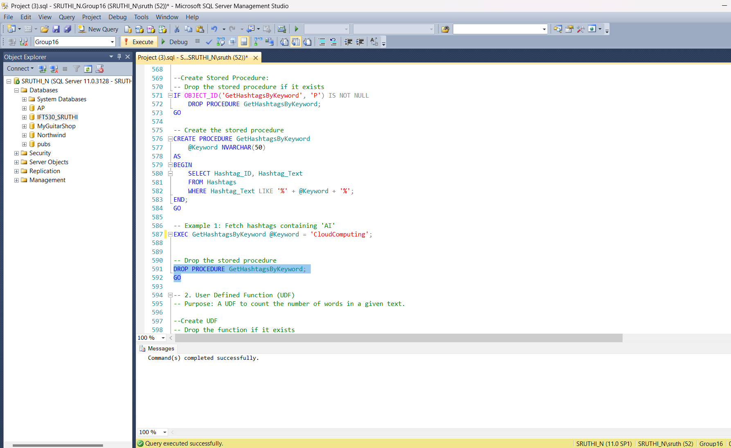

**2. User Defined Function (UDF)**

**Purpose: A UDF to calculate the engagement rate based on likes, shares, and views.**

/*

** Author: Group 16 (Jahnavi Lasyapriya Vavilala, Sruthi Keerthana Nuttakki)

** Course: IFT/530

** SQL Server Version: Microsoft SQL Server 2012 (SP1)

** History

** Date Created Comments

** 12/01/2024

*/

-- 2. User Defined Function (UDF)

-- Purpose: A UDF to count the number of words in a given text.

--Create UDF

-- Drop the function if it exists

IF OBJECT_ID('CalculateEngagementRate', 'FN') IS NOT NULL

DROP FUNCTION CalculateEngagementRate;

GO

-- Create the function

CREATE FUNCTION CalculateEngagementRate

(@Likes INT, @Shares INT, @Views INT)

RETURNS DECIMAL(5, 2)

AS

BEGIN

RETURN CASE

WHEN @Views = 0 THEN 0.00

ELSE CAST((@Likes + @Shares) AS DECIMAL(5, 2)) / @Views * 100

END;

END;

GO

-- Example in combination with Post_Analytics table

SELECT Post_ID,

dbo.CalculateEngagementRate(Likes_Count, Shares_Count, Views_Count) AS EngagementRate

FROM Post_Analytics;

-- Drop the function

DROP FUNCTION CalculateEngagementRate;

GO

**Created the User Defined Function:**

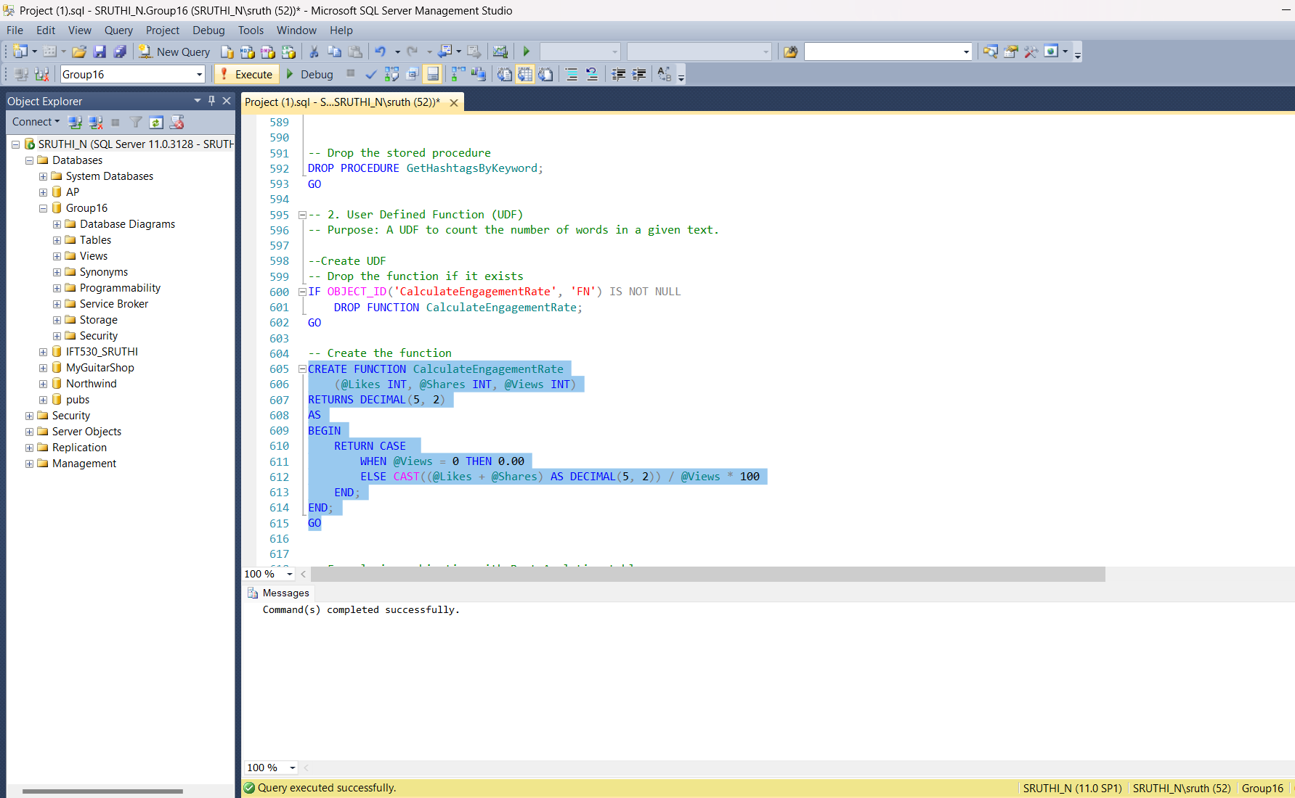

**Example in Combination with Post_Analytics Table:**

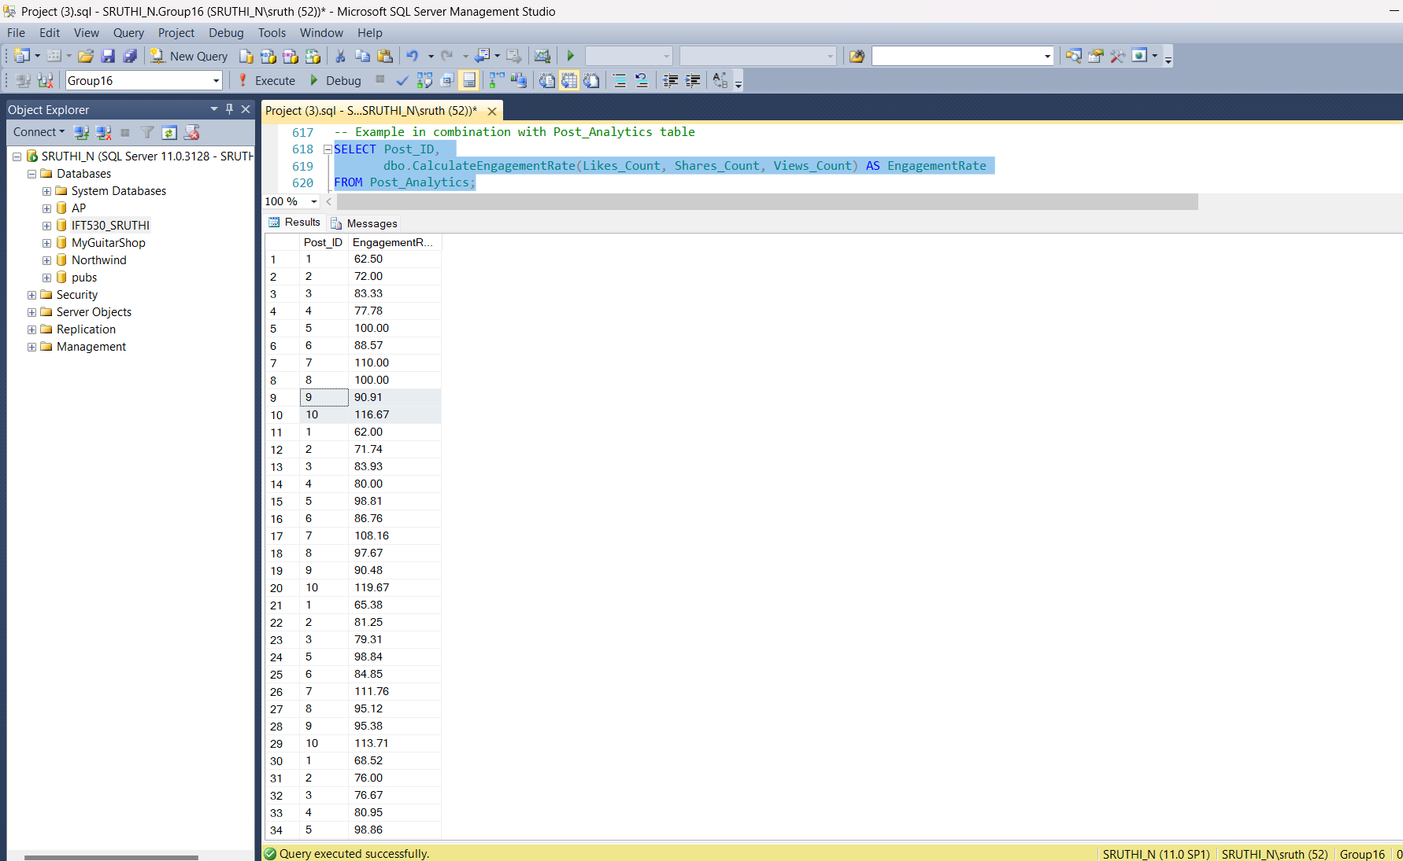

**Dropping the Function.**



**Task 7: Demonstrate the use of one cursor for your database. Create and drop script for cursor.**

#### **Purpose of the Cursor:**

The cursor is designed to process each row of data in the Sentiment_Scores table, joined with the Posts table, to dynamically update engagement rates in the Post_Analytics table based on sentiment thresholds. This approach is helpful when you need to apply business logic row-by-row, which cannot easily be achieved with a single set-based query.

#### **Step-by-Step Breakdown of our implementation:**

1. Variable Declaration  
   The variables @Post_ID and @Sentiment_Score are declared to hold values for each row fetched by the cursor. These correspond to the post's unique identifier and its associated sentiment score.
2. Cursor Declaration
   * The SentimentCursor is declared to retrieve Post_ID and Sentiment_Score from a join of the Sentiment_Scores and Posts tables.
   * This join ensures only valid posts with sentiment scores are processed.
3. Cursor Operation
   * Open the Cursor: The OPEN statement initializes the cursor, making it ready to fetch rows.
   * Fetch Rows: The FETCH NEXT command retrieves the first row of data and assigns values to the variables. This process repeats until there are no more rows to fetch (@@FETCH_STATUS = 0).
   * Business Logic: For each fetched row:
     + If the sentiment score is greater than 0.5 (positive sentiment), the engagement rate for the corresponding post is increased by 5.
     + If the sentiment score is less than -0.5 (negative sentiment), the engagement rate is decreased by 5.
     + The UPDATE statement ensures these changes are reflected in the Post_Analytics table.
   * Iteration: The cursor iterates through the dataset row-by-row, applying the logic to each post.
4. Closing and Deallocating the Cursor
   * The CLOSE statement releases the cursor from use, and DEALLOCATE removes it from memory. This step is essential for maintaining database efficiency and avoiding resource leaks.

**Code:**

/*

** Author: Group 16 (Jahnavi Lasyapriya Vavilala, Sruthi Keerthana Nuttakki)

** Course: IFT/530

** SQL Server Version: Microsoft SQL Server 2012 (SP1)

** History

** Date Created Comments

** 12/01/2024

*/

--Task 7

-- Declare variables to hold data

DECLARE @Post_ID INT, @Sentiment_Score DECIMAL(3, 2);

-- Declare the cursor

DECLARE MyCursor CURSOR FOR

SELECT Post_ID, Sentiment_Score

FROM Sentiment_Scores

WHERE Sentiment_Score <> 0; -- Only rows with a non-zero sentiment score

-- Open the cursor

OPEN MyCursor;

-- Fetch the first row

FETCH NEXT FROM MyCursor INTO @Post_ID, @Sentiment_Score;

-- Loop through each row

WHILE @@FETCH_STATUS = 0

BEGIN

-- Print the fetched data (or apply business logic)

PRINT 'Post ID: ' + CAST(@Post_ID AS VARCHAR) + ', Sentiment Score: ' + CAST(@Sentiment_Score AS VARCHAR);

-- Fetch the next row

FETCH NEXT FROM MyCursor INTO @Post_ID, @Sentiment_Score;

END;

-- Close and deallocate the cursor

CLOSE MyCursor;

DEALLOCATE MyCursor;

/*

** Author: Group 16 (Jahnavi Lasyapriya Vavilala, Sruthi Keerthana Nuttakki)

** Course: IFT/530

** SQL Server Version: Microsoft SQL Server 2012 (SP1)

** History

** Date Created Comments

** 12/01/2024

*/

--Drop Cursor Script

-- Close and deallocate cursor if it exists

IF CURSOR_STATUS('global', 'SentimentCursor') >= 0

BEGIN

CLOSE SentimentCursor;

DEALLOCATE SentimentCursor;

END;

